REMOTE LEARNING – Guidance for Parents 2

Dear Parent,
Now that everyone has completed Week 4 of Remote Learning, we wanted to stay in touch with you and provide an update from St Brigid’s PS. Remember for your child to be marked present, there must be daily online engagement. In P1-P4 you must log on to their class Seesaw. Here you will find the tasks to do for the day and a teaching video/presentation from their teacher.
For Example – Primary 3 in Mathematics; Mrs Donaghy has taught Time (o’clock and half past), Money (up to 50p) and has started Place Value, in the next few weeks she will teach Fractions, Measures and Length.
In Phonics, Mrs Donaghy does a different spelling pattern, phoneme, each week (magic e and split digraphs o-e, i-e and a-e and the y/ee sound). Mrs Donaghy has also taught – Verbs.
So it is not enough to complete the photocopied booklet sent out for each class. It is essential that you engage online to learn new skills. It is also essential that children do some remote learning daily – rather than a huge glut at the weekend. Children need regular reinforcement and practice of their key skills. This builds their concentration and learning skills.

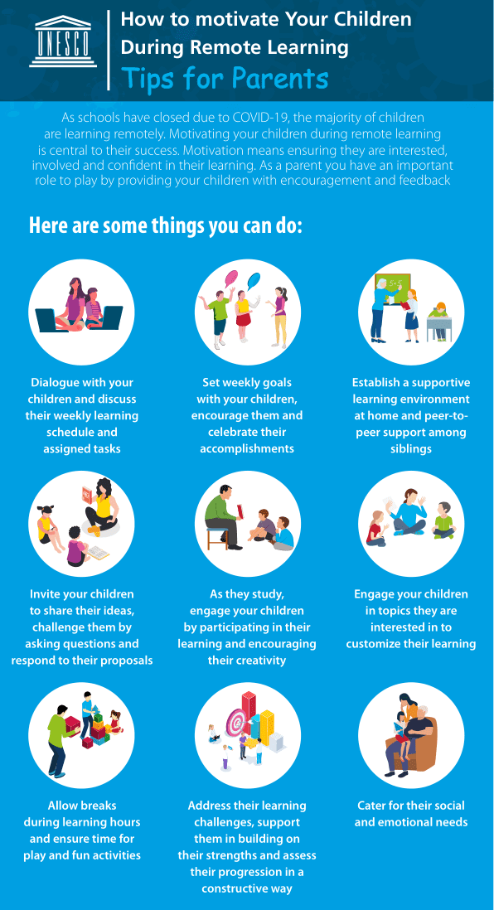

PARTICIPATION IN ONLINE LEARNING – WEEK 3 and 4.
 | Monday | Tuesday | Wednesday | Thursday | Friday
Week 3 | 91% | 92% | 91% | 94% | 89%
Week 4 | 91% | 92% | 92% | 90% | 87%

We are delighted with the increase in the number of children engaging with online learning either through Seesaw or Google Classroom. We are noting that we have fewer children online or work being submitted on a Friday. Last week, each day we had between 20 -32 children not participating – that is basically a class of children. They are missing so much and on their return to school, this regression will be obvious; in comparison to those children who are benefitting so much, from the one-to-one attention they get at home, which they do not get in a busy classroom.
You do not have to be a trained teacher, just your interest, time and effort are all that is needed.
Remote learning works best if you set a routine and do a little every day, not a week’s work in one sitting and then sending photographs to their teacher. This is detrimental to a child’s concentration level and attention span; and their reinforcement of key concepts and vocabulary must be practised regularly and consistently. We appreciate that you may be working shifts or working from home, but try to allow some time for your child’s remote learning each day.
P5 – P7 children must log in to their Google Classroom each day and complete all the assignments set in order to be marked present.
Your child’s attendance is recorded for each day that they submit the assigned work on the day that it was set by the teacher.

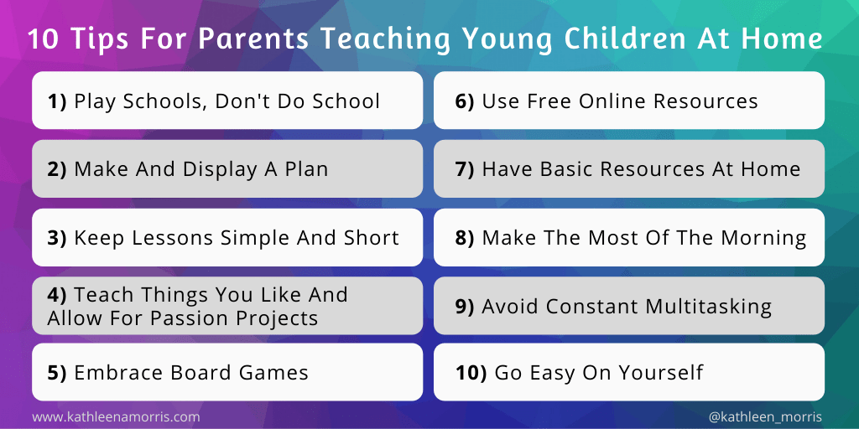

In Week 3 we celebrated Catholic Schools Week. Thank you for all the work submitted by your families – we have lots of drawings of grandparents and lots of prayers for them too. Well done everyone!
“In June 2020, Young Minds reported that 80% of young people agreed that the Coronavirus pandemic had made their mental health worse. This was often related to increased feelings of anxiety, isolation, a loss of coping mechanisms or a loss of motivation.”
In Week 4 we focused on Children’s Mental Health Week (1st – 7th February); we aimed to promote emotional wellbeing and positive mental health.
Step 1. Teach them to be themselves
Step 2: Be grateful
Step 3: Help them be more mindful
Step 4: Be kind
Step 5: Teach them the importance of resilience

During Week 5, on 9th February, we mark Safer Internet Day, take this opportunity to talk to your child about how to stay safe online.

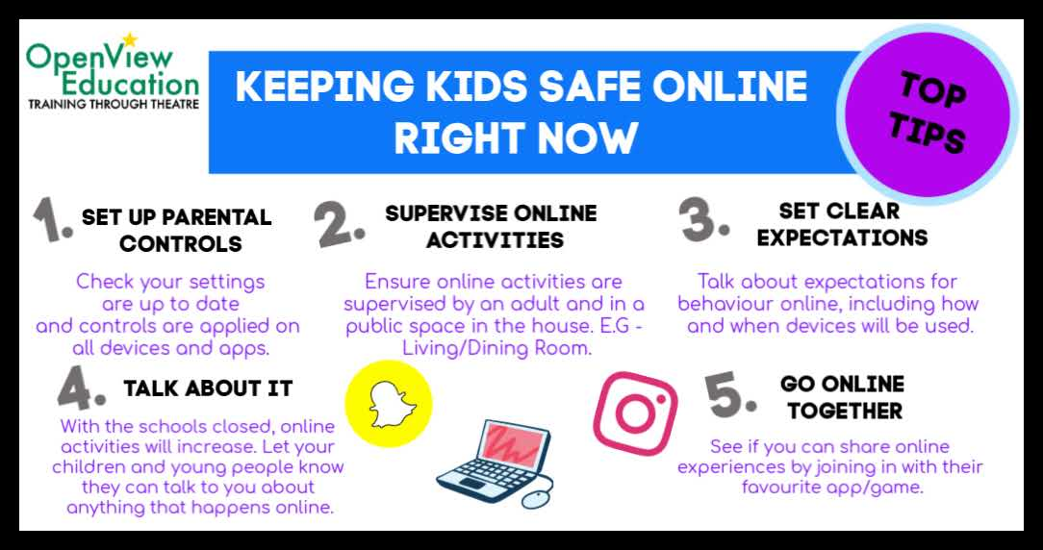

Allowing your children online can be quite scary. Here are some safety tips to help keep your kids safe online.
- Set up limits for which online sites your children can visit and for how long.
- Spend time surfing the Internet with your children and let them show you what they like to do online.
- Place your computer in a high-traffic common area of your home.
- Set up a plan to monitor mobile devices such as mobile phones, gaming devices and iPods.
- Keep an open dialogue with your children about online safety.
- Know who is connecting with your children online. Use tools to set cyber safe limits and to know who is contacting your child.
- Let your children know they can come to you if they see anything online that makes them feel uncomfortable.
- Tell your children that they can’t give out any personal information like name, address or school.
Remember your kids’ best online protection is YOU!

Three quick simple tips for keeping your children safe online, include:
+ Take it back to basics – if a stranger contacts you online, do not respond.
+ Remember, there are age limits on apps and websites for a reason, always make sure the apps on your child’s device is appropriate
+ Make sure your child knows if they are concerned about something they have seen or been in contact with online, they should talk to a trusted adult.

We hope to be back in the classroom on 8th March, but please keep working with your child each day in the interim.

There will be no remote learning during the week 15 -19 February inclusive as this is our mid-term break. Lessons will resume on Monday 22nd February.

We have been joined by three student teachers from St Mary’s University College, Miss Mc Erlean will be in Foundation Stage, Miss Young will be in Key Stage 1 and Miss Darragh will be in Key Stage 2. They will be assisting staff with online learning and putting up some short videos. We wish them well.

DEPARTMENT OF EDUCATION FOR NORTHERN IRELAND

FEATURES OF
EFFECTIVE PRACTICE
IN REMOTE LEARNING

COMMUNICATION AND RELATIONSHIPS
- A remote learning policy which provides guidance to parents and pupils on the school’s approach to remote learning.
- Engagement with pupils through appropriate digital platforms to allow for regular contact and ensure ongoing interaction, assessment and timely feedback.
- At pre-school and primary, a brief daily explanation of the work to be undertaken each day is provided to parents/carers and/or pupils giving a breakdown of daily activities, suggested timings and information on the resources needed.
- A flexible, indicative weekly timetable for parents and/or pupils detailing what areas of learning will be taught each day, with the areas which will involve online engagement identified clearly.
- Activities/work presented in a manner and pace that is manageable in the home context.
- When possible, opportunities for pupils to talk to or work with others in paired or group work.

PLANNING, LEARNING AND FEEDBACK
- A well-sequenced curriculum which enables good progression, prioritising key knowledge, understanding and skills in each area of learning and where the intended learning outcomes and success criteria are clear and shared with pupils and parents. For pre-school and foundation stage children, activities should be play-based.
- Pupils have meaningful work and activities each day in a number of different areas of learning for curriculum breadth and balance.
- Pupils are provided with clear, frequent explanations of new learning and curriculum content through the use of explanation by the class teacher supported with high quality curriculum resources and/or videos.
- Resources are available for pupils without ready online access, including through distribution of hard-copy materials which include guidance on completion of the activities, model explanations and answers to assist pupils and also parents in supporting their child’s learning.
- Lessons, activities and resources are differentiated appropriately to reflect pupils’ ability and needs in order to support positive and rewarding learning experiences.
- Mechanisms for providing timely, frequent and specific (oral or written) feedback to pupils on their work, as well as for supporting pupils should they need help in progressing their work.
- A wide range of formative assessment practices to check for knowledge, understanding and skills progression.
- Learning experiences for those pupils in attendance during the remote learning period which follow the curriculum programme of those undertaking remote learning at home.

SYSTEMS TO SUPPORT LEARNING
- A named senior leader with overarching responsibility for overseeing the Remote Learning programme, with subject heads or co-ordinators monitoring the quality and delivery of remote education.
- Systems for checking daily that pupils are engaging with their work.
- Procedures for monitoring work completion and engagement across the curriculum and to make contact with the parent or carer by email or telephone if a lack of engagement is highlighted.
- Policies such as safeguarding/child protection and use of ICT reviewed to reflect any changes in practice, and updates provided to staff and parents as necessary.

