St. Brigid’s P.S. Mayogall
Children’s Mental Health Week
1st – 7th February 2020
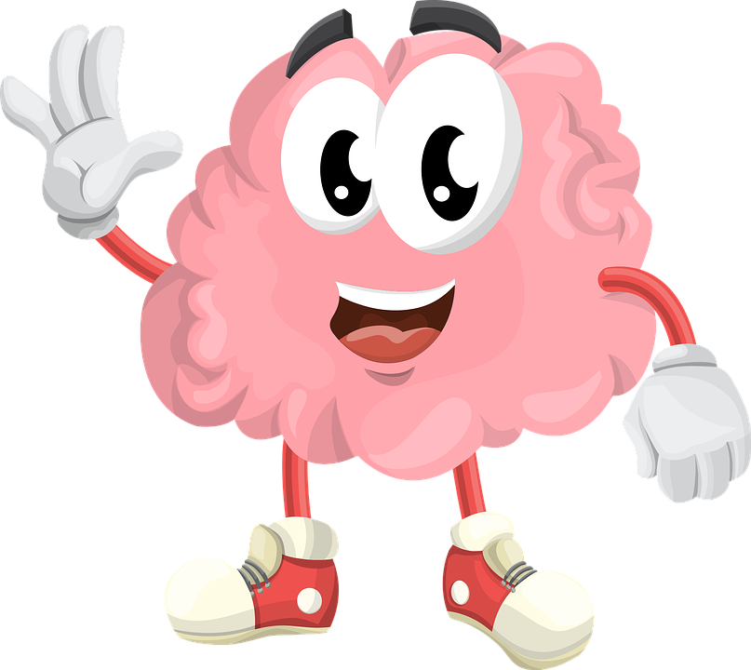

Monday 1st February – Starting Mental Health Week
St Brigid was known for her kindness. How can you show kindness today? Help to tidy the house? Do all your home learning without complaining? Sending a kind message to a friend? Telling your family how much you love them?
Colour this picture of St Brigid in a mindful way. As you colour, think about your breathing, breathe right into your belly and breathe out longer than you breathe in.

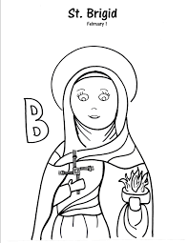

Thankful Tuesday

Thankful Tuesday
We all love to hear people say thank you, so who will you say thanks to today?
Years ago people used to write a letter to say thank you for a gift or when someone did something kind for them. Write a letter to say thank you:

Wishing on Wednesday
Wednesday is a bit of a sad day for some people – it is in the middle of the week; some people even call it ‘hump day’… We can feel better when we think about our future, our dreams, our plans our hopes and goals. What are you wishing for?

My wishes | My hopes | My goals

Thrilling Thursday
Our bodies and our minds work best when they work together. So if you exercise your body, it releases a chemical which makes your mind feel better – endorphins. So what can you do on this cold Thursday to thrill your body and mind?

- Run around your house 5 times without stopping or
- Do 20 star jumps or
- Jump on your trampoline for 3 minutes without stopping or
- Use a skipping rope – skip as long as you can or
- Bounce a ball without stopping for 3 minutes
When you have done this you should have red cheeks, you should be able to feel your heart beating faster and you should be breathing more deeply.
Now how is your mind feeling?

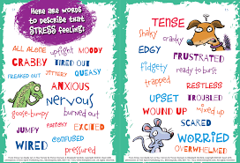
Hopefully, any bad feelings have gone and you are feeling the thrill of exercising. Big smile – tell your body and brain how happy you feel!

Friendly Friday
In school, you get to see your friends every day, you can play with them at break time and lunch time. Now that you are learning at home, many people are missing their friends, some people even miss their teachers! We know that it is hard to be at home, to stay at home to stay safe. But even though we cannot see our friends every day, they haven’t disappeared. Hopefully, we will be back at school soon. So colour a picture that looks like your best friend and write down what you miss most about them……
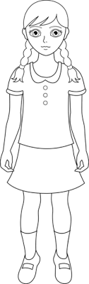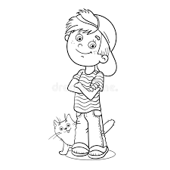

Sleepy Saturday!
Hip Hip Hooray
It’s Saturday!
Saturday should be your day for you! No home schooling, no uploading work to your teacher on Seesaw or Google Classroom. This is your day to rest, relax and chill doing the things that make you happy. So whether you are watching television or playing on a device, doing a jigsaw, reading a book, or going for a walk or cycle with your family – remember today is all about YOU! Draw a picture of what you are doing today that makes you HAPPY!

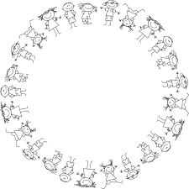
Super Sunday
Today is a spiritual day – many people would go to Mass – if only churches were open. Perhaps you and your family can log in and join Fr Graham as he celebrates Mass at 9am or 11am?

As we come to the end of Children’s Mental Health Week it is time for you to be proud of all that you have achieved this week.
Remember what Fitness Freddy taught us:- TAKE 5
- Give
- Take Notice
- Keep Learning
- Be Active
- Connect

Always talk about how you feel? Who is your trusted friend – mum, dad, grandparents, teacher, a friend?

If you feel sad, unhappy, alone, fed-up, frightened, scared, miserable, tell someone you trust. Together, we can deal with sad feelings and unhappy thoughts. Remember our school motto – le cheile in eolas – together in learning.

