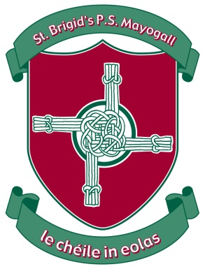 St Brigid’s Primary School

Website: www.stbrigidsmayogall.ik.org

St Brigid’s Bulletin

News Letter

September / October 2020

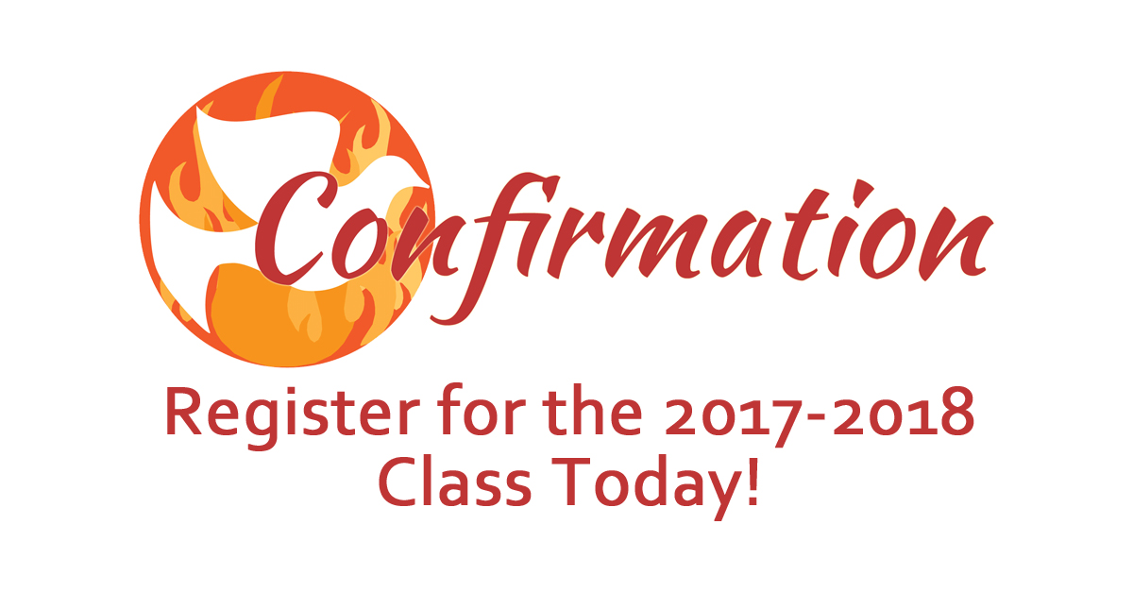

On Thursday 20th August our 38 Primary 7 pupils received the sacrament of Confirmation in Our Lady of Mercy Church. They spent three mornings in rehearsals and then performed brilliantly on the evening. Thank you to all our readers, singers and those who participated in the ceremony and to Mrs O’Hara, Louise and Gillian who prepared the children to receive the sacrament.

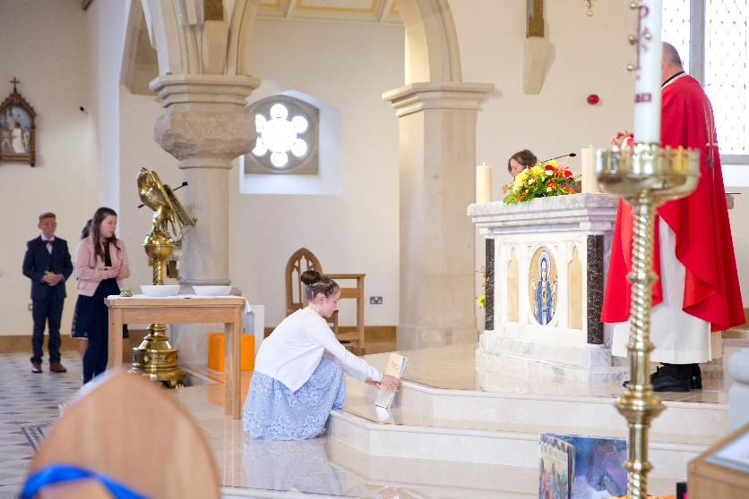

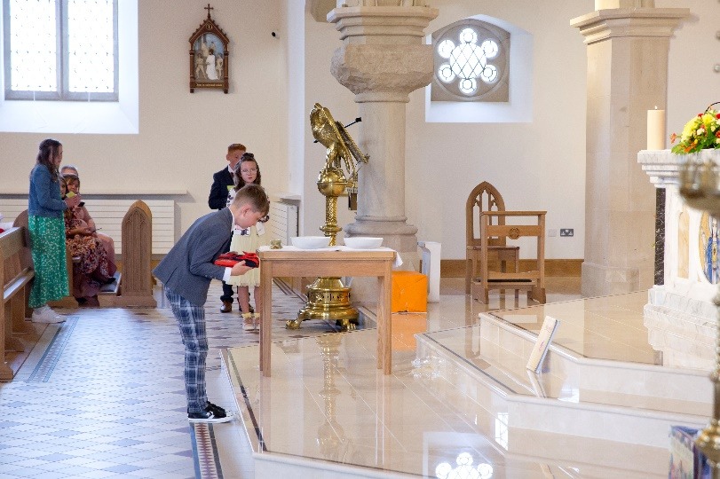

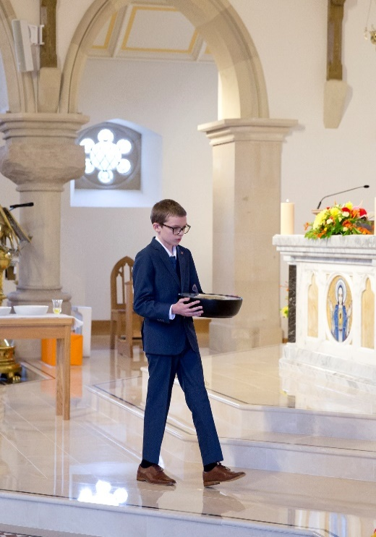





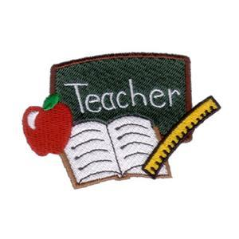**Term 1 Takes off:**

Term started on Monday 24th August with 256 pupils enrolled. We were joined by

37 new Primary 1 pupils we also welcomed Callum Duggan to P2.

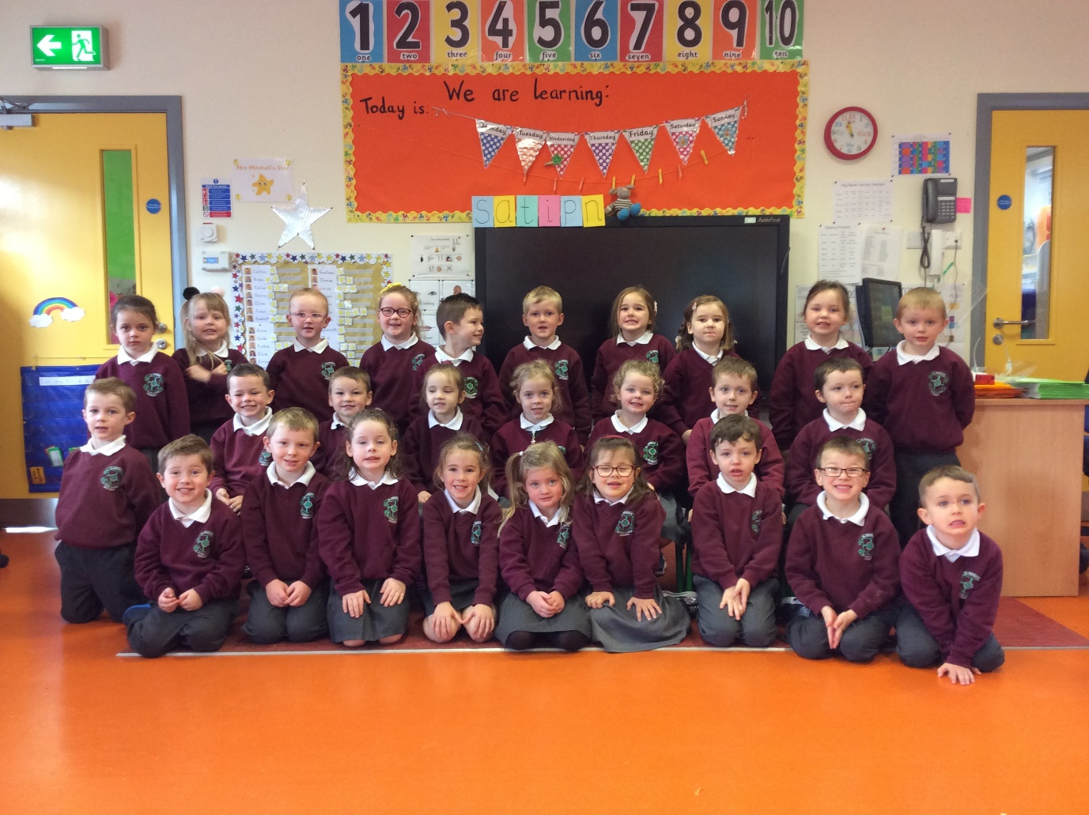

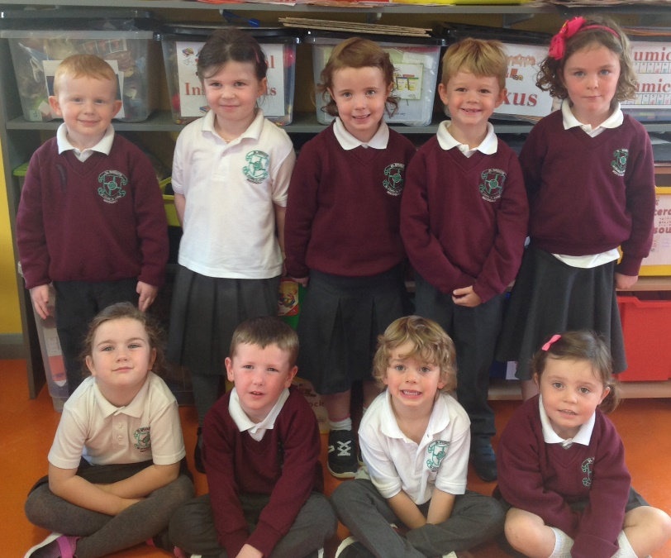



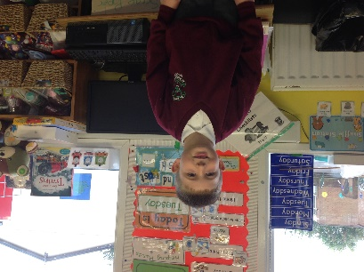



**New Staff Joining our staff team:**

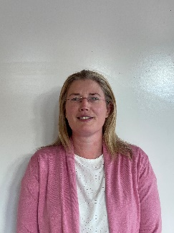



We have a number of new staff who have joined us

this academic year. They are Mr James Lagan in

P3/4 composite class which was set up until Hallowe’en

to ease our 33 P3 pupils into school. Kate O’Neill,

Johann Rainey, Catherine Toner and Kate Quigley

are our new Classroom Assistants.

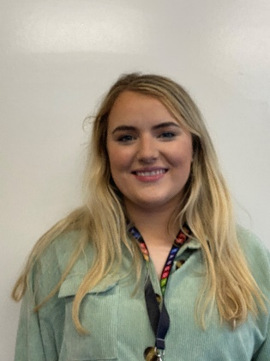

**First Holy Communion:**

On Saturday 12th September our present P5 girls and boys made their First Holy Communion. The sun shone on the morning and the beautiful ceremony was enhanced by the singing of our seven past pupils. Again all pupils participated so well in the ceremony. Thanks to Mr Doherty, Clodagh and Kate for all their hard work in preparing the children.



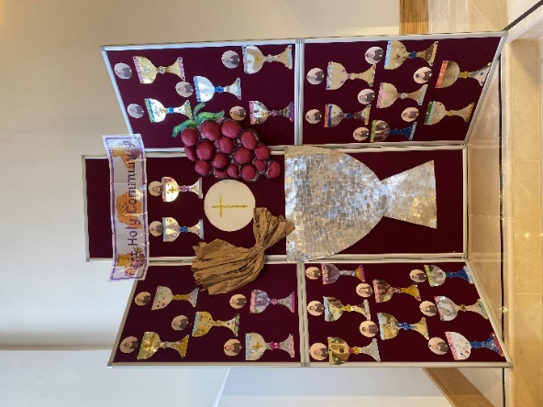

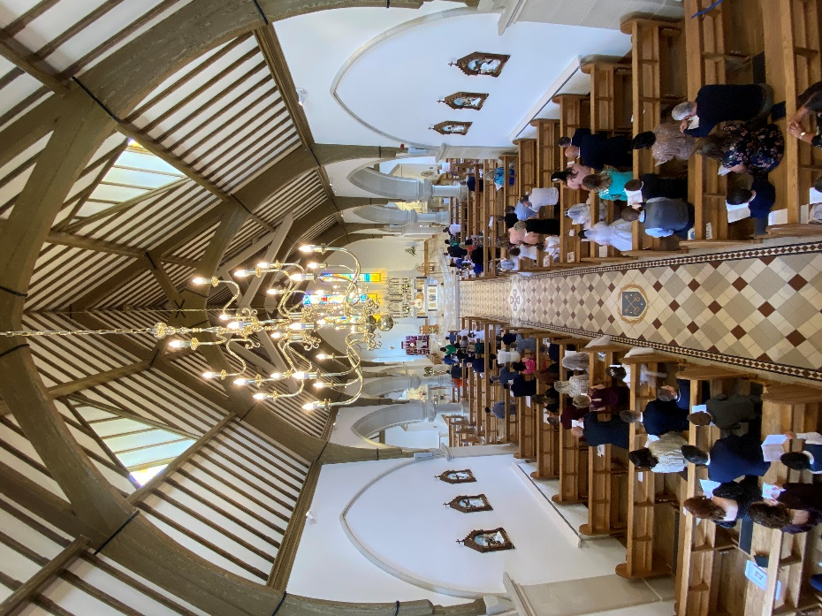



**Start of Year Mass:**

Our start of year Mass came live this year on Friday 25th September from St Eugene’s Cathedral Derry. The celebrant was Bishop McKeown.

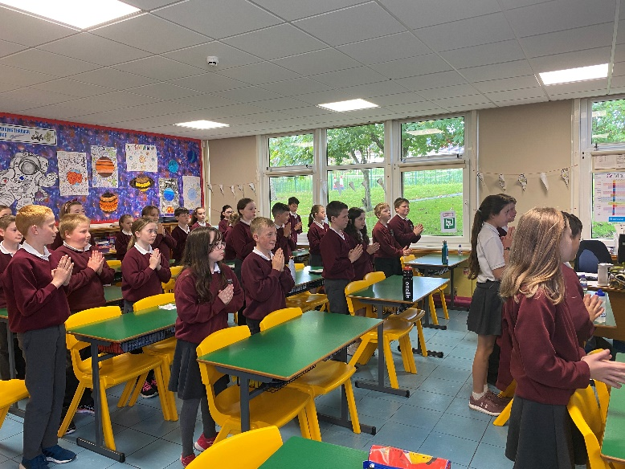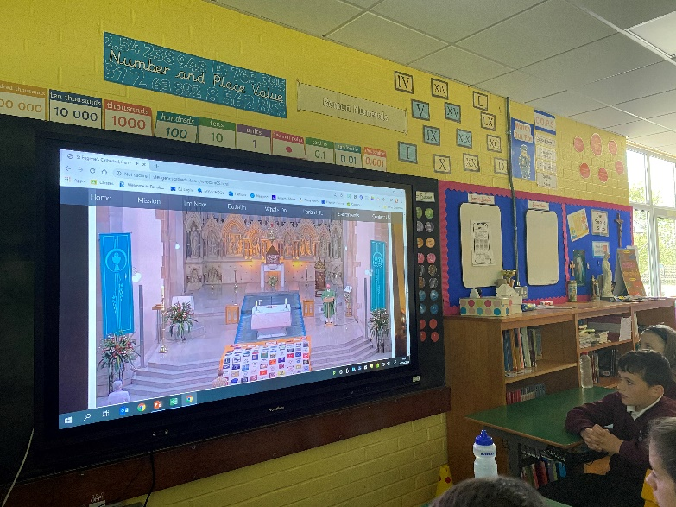

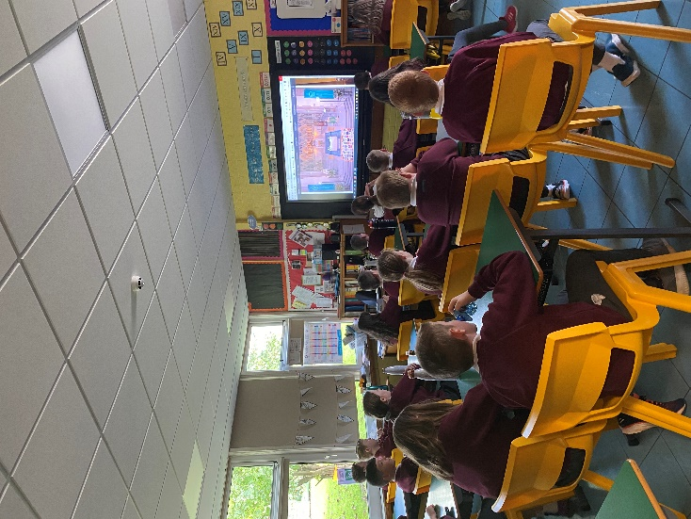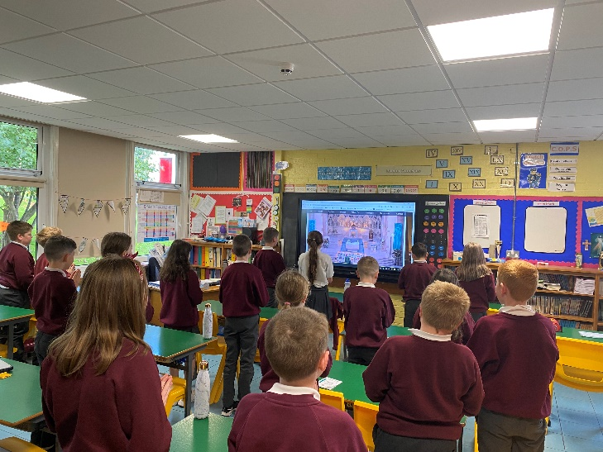

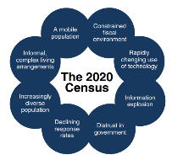**School Census:**

On the 9th October the annual DE school census took place. In St. Brigid’s we had 256 pupils,

122 boys and 134 girls. 11 pupils had a Statement of Educational Needs.

**Hurling Jerseys:**

Thank you to Erin’s Own Hurling Club for their very generous donation of a set of Hurling jerseys for our school team. We appreciate the hard work of Shaune Duggan and Michael Collins in the design and purchase of the jerseys. At this stage we are unsure when school competitions will begin, but we thank Erin’s Own for their continued support. We are very fortunate to have such a supportive G.A.A. club, and the use of their excellent facilities.

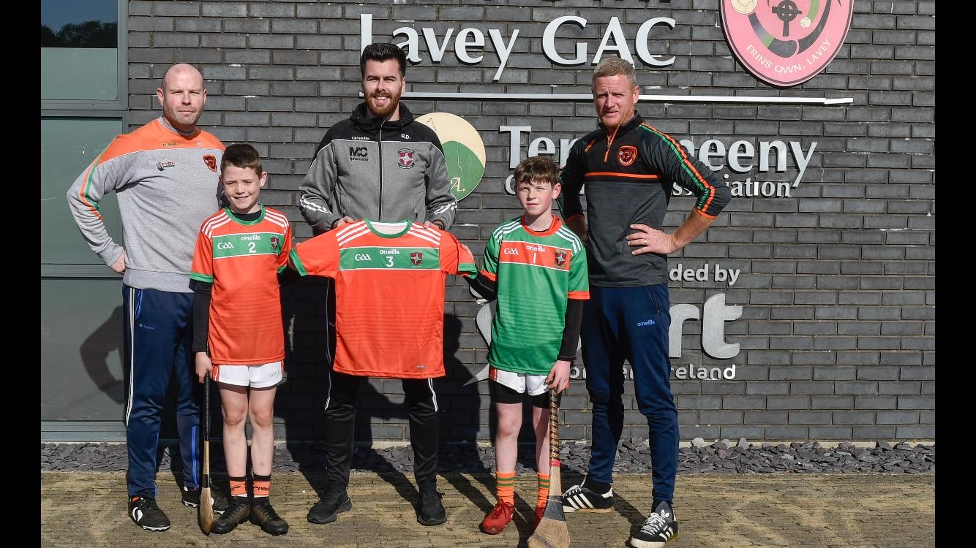

**Parent Teacher Meetings:**

Parent Teacher Meetings would normally be held in the week before our Hallowe’en holidays. This year due to Coronavirus restrictions, teachers hope to discuss children’s progress with parents in January 2021.



We are currently in our fifth year of the J.D.O. programme. We have partner schools in New York, Denver, Florida and Reading. Primary 7 pupils are partnered with Promise Academy Harlem, New York. Primary 6/7 pupils are partnered with Blessed Sacrament Catholic School, Denver. Primary 6 pupils are partnered with Pelican Isle, Florida. Primary 5 pupils are partnered with Purley Church of England Primary School, Reading.

All Key Stage 2 children have a partner that they communicate with regularly using their Google Chromebooks. The children complete a range of Literacy, Numeracy and World Around Us activities each month with their partners. We are very grateful to the J.D.O. Foundation for supplying our pupils with a Google Chromebook.

The use of our JDO Chromebooks has placed us in a very good positon for distance/blended learning and our children and staff are highly competent in ICT.

ERASMUS +

Thanks to Mrs O’Hara for her very had work on the completion of two Erasmus+ Projects, due to start this Autumn. The pass mark was very high, the forms were a bureaucratic nightmare, to have both accepted is an amazing feat for our school! How travel will work post-Covid, we have no idea, but look forward to working with our European partner schools.

|  |  |
| --- | --- |
| **Project 1 STEAM** | **Project 2 Entrepreneurship** |
| Spain - CEIP Victoria Diaz | Greece - 4Dimotiko Sxolelo Lamias |
| Croatia - Osnova Skola Glina | Spain - CEIP la Santa Cruz |
| Poland - Szkola Podstawowna Wjciecha | Italy - Istituto Comprensivo G. Toniola |
| Ireland - St Dominic’s NS Tallagh | Finland - Myllyojan Koulu, Oulun Kaupunki |
| Iceland - Grandaskoli Reykjavik | Sweden - Apelgardsskolan |

**Project 1** is designed to enhance ICT skills through STEM activities. The project will provide opportunities for integrated learning, hands on discovery and adaptations to ensure lessons will reach all students and their ability levels.

**Project 2** is aimed to open the minds of pupils in Primary Schools to the joy of entrepreneurship. The project will provide pupils with a set of skills that they will need to enhance their future employability. Pupils will be encouraged to own and run their own mini-business.

**Staff Training:**

In St Brigid’s P.S. we give a high priority to the professional development of all our staff. Listed below is a number of training and development events attended by staff:

August 17th – 21st Baker Days

September 10th M O’K to Cluster Meeting

23rd Charlene Community Nurse to train U Q, C D and A McG

29th  Charlene Community Nurse to train R McD, J R, C T and P McC

October 1st M O’K Cluster Meeting

In addition, lots of our staff training has been online through Webinars, Meets, Teams or Zoom.

Dates For Your Diary:

19th – 30th October 2020 Halloween break

21st December 2020 – 1st January 2021 Christmas holidays

15th – 19st February 2021 Mid-term break

17th March 2021 St Patrick’s Day

1st April – 9th April 2021 Easter Holidays

3rd – 7th May 2021 May Holidays

31st May 2021 Bank Holiday

The school year ends on 25th June 2021

The School Website!

**Our school website is a valuable source of information. Please check it regularly.**

**Log on to** [**www.stbrigidspsmayogall.com**](http://www.stbrigidspsmayogall.com) **and see all our information.**

**We are adding information to our site so remember to check in regularly for updates.**

**In addition to school news there will be a class area where you can see samples of work.**

**In the Parents Area you will find:**

* **The School Calendar**
* **Dinner Menu**
* **Newsletters**
* **Holiday List**

**Our website is linked to our social media sites Facebook and Twitter. In addition, there will be a school App which you can download so that all the latest news will go straight to your phone!**

**Get school updates via your phone**

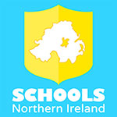

Our school is now listed in the **Schools NI** app, which allows you to view school updates and receive messages via your phone or tablet. The app is available on both Apple and Android devices, and will give you access to our school news, calendar events and letters.

To install the app, open **[School Website]** on your phone or tablet and click the ‘Download App’ button that appears at the top of the screen.

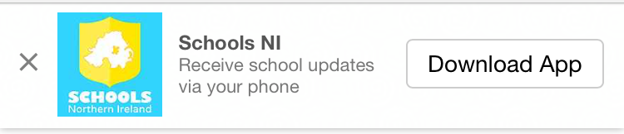

Next time you open the Schools NI App our school will be listed at the top of the list. You don’t need to have the app open to receive messages.

**Log on and look in . . . . . .**