#### StSt Brigid’s Primary School

Website: www.stbrigidsmayogall.ik.org

St Brigid’s Bulletin

News Letter

March / April 2020

**Birds of Prey:**

On Wednesday 4th March we had an exhibition of birds of prey including a young barn owl, wood owl, kestrel and Harris hawk. All our pupils enjoyed seeing and hearing about these birds.

**Service of Light and Enrolment Ceremony:**

On Thursday 5th March the Primary 4 and Primary 7 children had their Enrolment and Service of Light as they prepare for the Sacraments of First Penance, Holy Communion and Confirmation.

**World Book Day**

To celebrate World Book Day on Thursday 5th March, we have a number of events planned. We begin our day with a Reading Assembly, following which, the winners of the Extreme Reading Competition were presented with their prizes.

**Favourite Book:**

Pupils had to bring in their favourite book so they can tell their classmates all about it.

**Book Swap:**

Pupils from P3 – P7 brought in a book that they would like to swap with a classmate. “Give a book – get a book.”

**Book Amnesty:**

We spend lots of money buying new text books especially reading books; however, each year a number of books are lost/mislaid.

**The Romans:**

Primary 5/6 pupils have been studying the Romans. They have been investigating STEM (Science, Technology, Engineering, Maths) through the topic and have used their knowledge to design and build chariots, pottery and catapults.

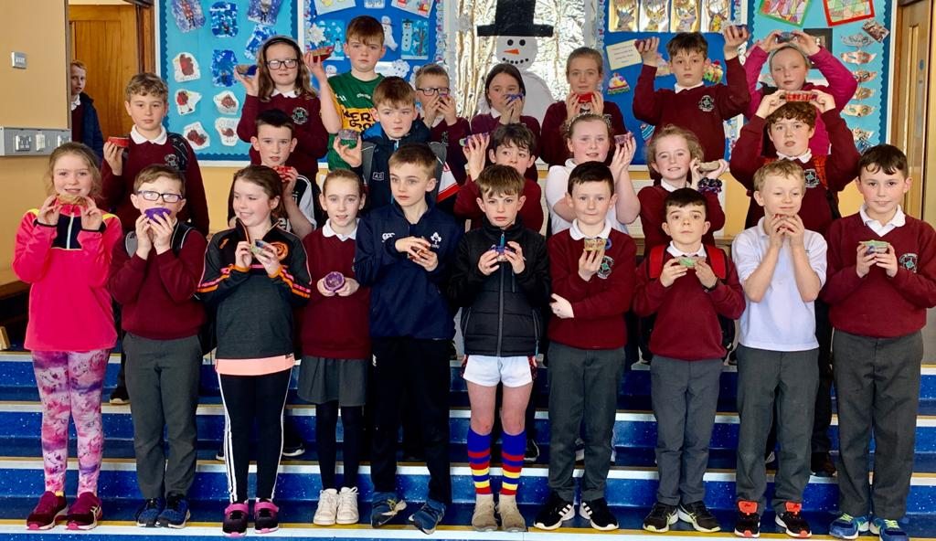

**Merit Assembly:**

Our February Merit Assembly was held on Friday 6th March. Our Merit Assemblies are held to celebrate pupil success in all aspects of school life. Award Winners were:

P1 - Charlie McCormick, Sarah-Jane Duggan, Ciaran Hughes, Roisin Shivers

P1/2 - Noah McPeake, Eireann Collins, Erica Davey, Cara McHugh

P2 - Roíse Melaugh, Shay Cushnahan

P3 - Sadie Birt, Dylan Stokes, Oliver Trainer, Aoibhe Burke

P4 - Daniella McDonald, Sadie Taylor, James Larkham

P5 - Riona McNeill, Daithi Holleran, Conor Smith

P5/6 - Aleksandar Samardzija, Roise Kearney, Conan Boyle, Charlie Birt

P6 - Rian Downey, Seamus Og Woulahan, Maria Conway, Charley McGarvey, Aoife Brennan,

Ella McErlain

P7 - Aine Young, Sinead McErlean, Aideen Currie, Ronan Duggan

**Accelerated Reading Awards:**

P5 - Niamh McPeake, Aoife Boorman, Oran Currie, Conor Donaghy

P6 - Pete Broderick, Erin Hughes

P7 - James McPeake, Ella Hughes

**First Confessions:**

On Monday 9th March our Primary 4 pupils made their First Confession in Our Lady of Mercy Church Lavey. Fr. Graham congratulated the P4’s and commended their teachers Mrs Quinn and assistants Clodagh and Colleen for their preparation of the pupils to receive the Sacrament. The evening was a huge success with Fr Graham hearing confessions. The service was enhanced by the beautiful singing of the school choir.

**Dairy Council:**

On Wednesday 11th March the Dairy Council came in to visit our Primary 5 and 6 pupils to tell them about the importance of a healthy diet which includes protein, fruit and vegetables. The pupils learned about the role of dairy products in maintaining healthy bones, skin and growth through music and dance. They had a blast!!

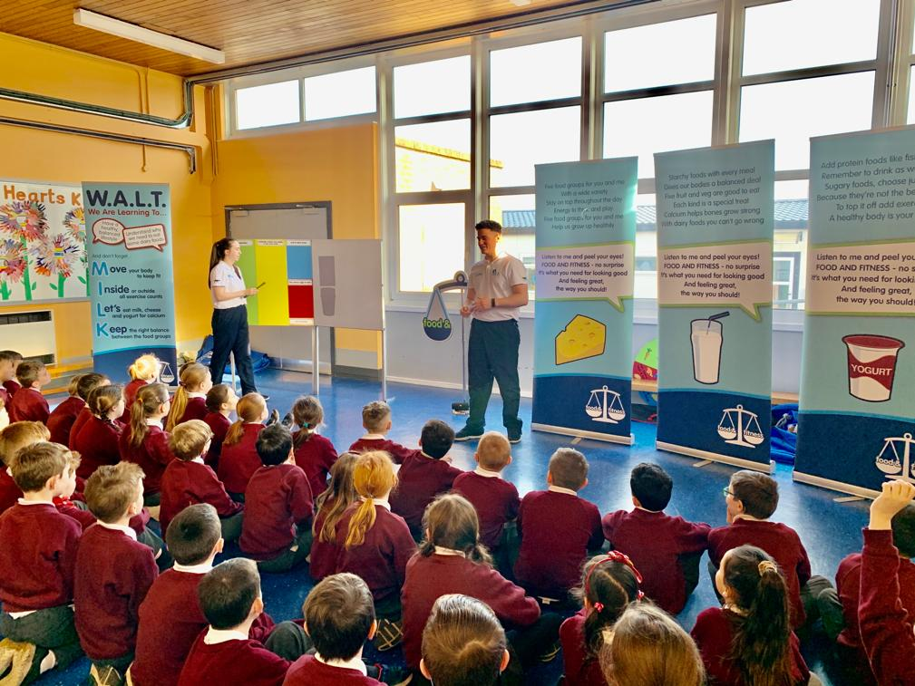

**P7 Residential**

**P7 Shared Education Residential:**

Wednesday 11th – Friday 13th March saw our P7 pupils visit the East Coast Adventure Centre in Rostrevor. The children completed a wide variety of activities including: banana boating, kayaking, team building activities, disc golf, wall climbing, archery, wet river bouldering, pier jumping, zip-lining, forest walk and the night line. Mrs O’Hara, Mr Doherty and Miss Dobbin were so impressed with the bravery of our pupils as they tried all the activities. **Well done P7!**

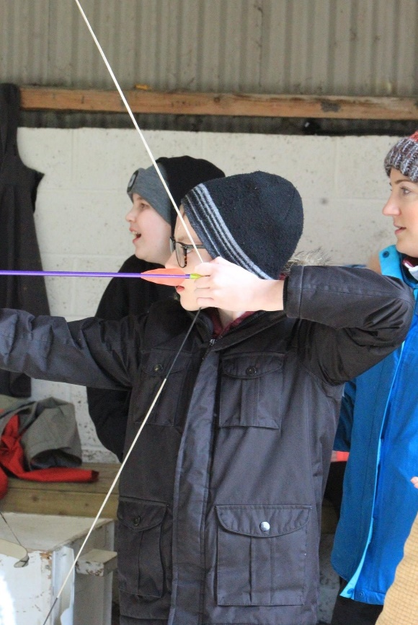

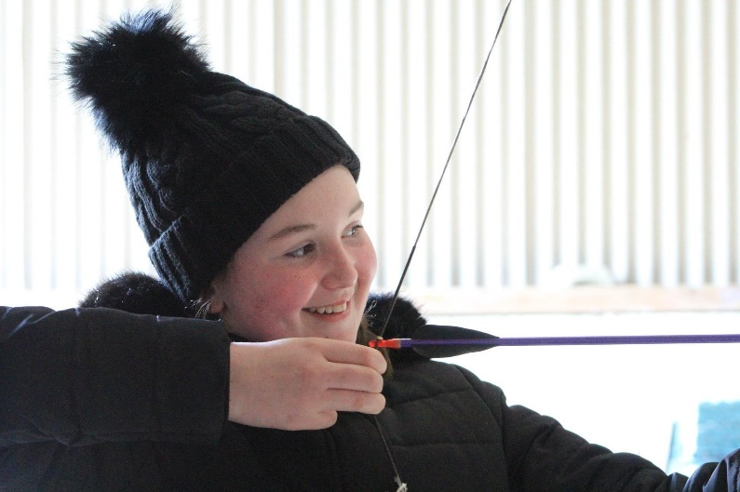

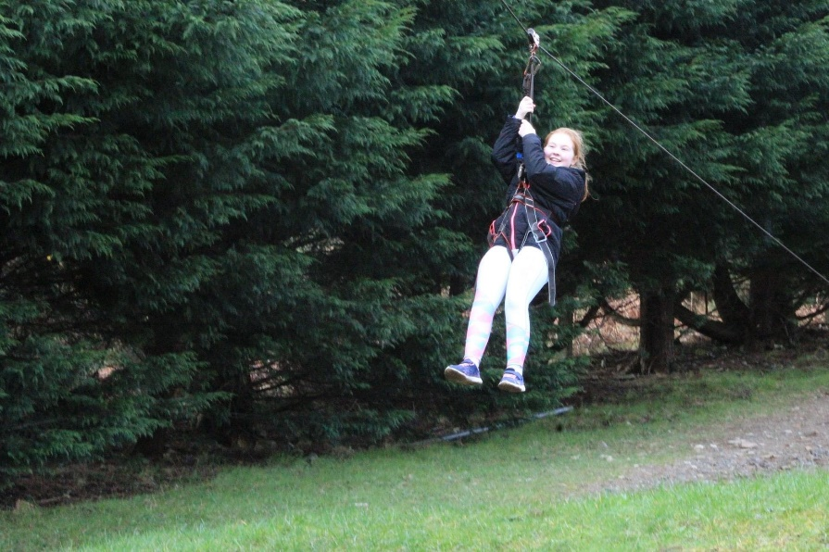

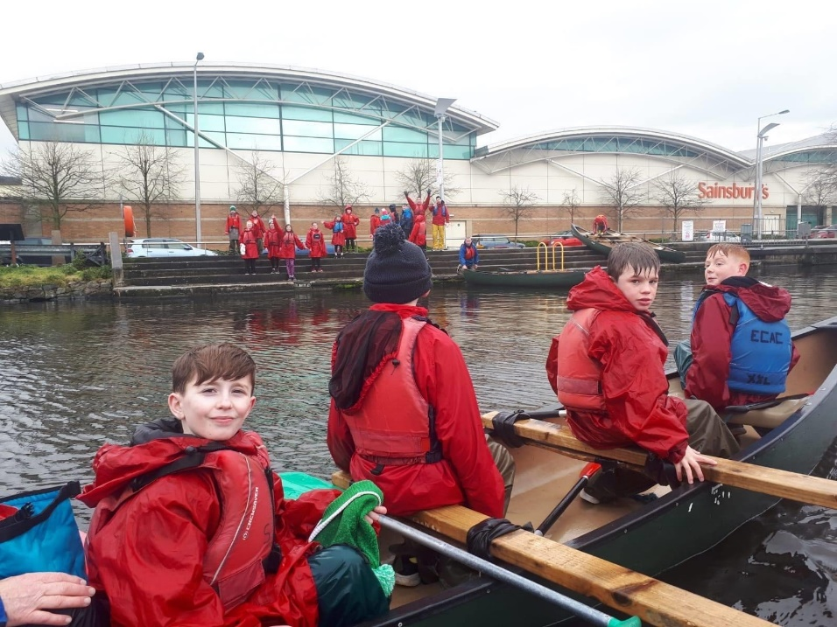

[](http://www.google.co.uk/url?sa=i&rct=j&q=&esrc=s&source=images&cd=&cad=rja&uact=8&ved=0ahUKEwiX4LqT1cLLAhVExRQKHShAD6MQjRwIBw&url=http://www.clipartpal.com/clipart_pd/holiday/stpatrick/shamrock2.html&psig=AFQjCNEVpckh5_k-yblRwkQ7bKnpVYUGUQ&ust=1458130384194568)

**17th March Break:**

**Both staff and pupils enjoyed another short break.**

**School officially closed from Monday 23rd March 2020 due to the outbreak of Coronavirus.**



**Quizzes**

**Northern Ireland Primary Schools Road Safety Quiz Finals:**

The children were back in Cookstown for the NI Road Safety Final on Monday 2nd March when twenty-two teams were again quizzed over eight rounds, mainly on road safety matters but with several other novelty type rounds and anagrams, recognising celebrities from partial facial photographs. When the scores were totalled the Mayogall team had the third highest score, but with a tie for the second highest St Brigid’s P. S. finished in 4th place. Aideen, Anton, Henry and Sadie had worked very hard and all were proud of their achievement in bringing the school to the final for the third consecutive year.

**Cross countrY**

**Cross Country Training Session:**

Representatives from Flahavan’s Cross Country organisation James Hamilton, Catherine Ashford, Allister Woods and John Glover came to school on Tuesday 3rd March to coach our cross country pupils and they all received a Flahavan’s goodie back.

**Staff Training:**

In St Brigid’s P.S. we give a high priority to the professional development of all our staff. Listed below is a number of training and development events attended by staff:

March 6th A McG to SEN course in ABC



**Dates for your Diary:**

* **School closed 4th May**
* **All County Camogie Championships at Owenbeg 5th May**
* **Sports Day Practice 7th May**
* **Sports Day 8th May**
* **Boys’ Football Championship at Glen 19th May**
* **School closed 25th and 26th May**
* **St Piux X Induction/Fun Day 2nd June**
* **All County Hurling Championships at Owenbeg 2nd June**
* **Girls’ Football Championship Day at Glen 3rd June**
* **P7 Fan the Flame Mass 4th June**
* **First Holy Communion 6th June**
* **St Patrick’s College Testing Day 8th June**
* **St Patrick’s College Testing Day 11th June**
* **Castle Cup Football 12th June**
* **Castle Cup Hurling and Camogie 16th June**
* **Track and Field at Meadowbank 18th June**
* **All County Boys’ Football Finals Night at Owenbeg 19th June**
* **End of Year Mass 26th June**
* **School Finishes at 1pm on 30th June**