#### StSt Brigid’s Primary School

Website: www.stbrigidsmayogall.ik.org

St Brigid’s Bulletin

News Letter

January / February 2020

**Term 2 Takes off:**

Everyone started back for Term 2 on Monday 6th January, with lots of New Year’s resolutions that 2020 would be a great year for us! All pupils and staff walked up to Our Lady of Mercy Church for Mass for the feast of the Epiphany.

Pupils participated in the Liturgy and the school choir under the direction of Mr Sean Scullion added to this special Mass.????

[](http://www.google.co.uk/imgres?imgurl=http://rescov.org/wp-content/uploads/2011/01/epiphany-email.png&imgrefurl=http://rescov.org/worship/epiphany/&h=200&w=600&tbnid=i2WY2kEh1RGGjM:&zoom=1&docid=ldnu8eILr5M3sM&hl=en&ei=0sD5VOj7EOmu7Ab1p4A4&tbm=isch&ved=0CDIQMygOMA4)

**New Online Admissions:**

The new online admissions process for our new P1 pupils for September 2020 became live on Tuesday 7th January at 12noon and closed again on Thursday 30th January at 12noon. We have 39 applicants for 35 places and are hopeful that they all be granted a place in St. Brigid’s.

**Teaching Practice:**

We had two students on teaching practice from St Mary’s University College Belfast Lauren Elliot in P3 and Faoilitiarna Burke in P2.

**Fireman visit to P5 pupils:**

Terry Scott from Maghera Fire and Rescue Service came into visit Primary 5 on Wednesday 22nd January. He informed the children about Fire Safety around the house and what to do in the case of an emergency. Each child received a safety team pack with games and activities to help them keep safe.

**GL Results:**

On Saturday 25th January

**After School Clubs:**

BD07157_SL00380_On Monday 27th January we started another term of After School Clubs to run for 8 weeks finishing on Friday 27th March.

**Term 2**

|  |  |  |  |
| --- | --- | --- | --- |
| **DAY** | **ACTIVITY** | **FACILITATOR** | **AGE GROUPS** |
| Monday | Boys’ Football  Mindfulness Colouring  P6 Girls’ Games | Mr R. Doherty  Miss C. Logue  Mrs G. O’Hara | P6 – P7  P4 – P5  P6 |
| Tuesday | Quiz  Cookery  Camogie | Mr F. Kelly  Miss L. Elliot  Miss C. Traynor | P6 – P7  P5  P4 – P5 |
| Wednesday | Girls’ Gaelic  Camogie  Football | Mrs G. O’Hara  Miss G. Dobbin  Mr H. McGurk | P6 – P7  P6 – P7  P4 – P5 |
| Thursday | Hurling  Girls’ Robotics & Coding  Girls’ Football | Mr R. Doherty  Mrs G. O’Hara  Miss C. Traynor | P6 – P7  P7  P4 – P5 |
| Friday | Cross-Country  Hurling | Mr F. Kelly  Miss C. McKenna  Mr H McGurk | P5 - P7  P4 – P5 |

**Thanks to all our staff who give so generously of their time and talents.**

**CATHOLIC SCHOOLS’ WEEK**

We celebrated Catholic Schools’ Week from 26th January to 1st February. This year’s theme was **‘Living in Harmony with God’s Creation’**. At St Brigid’s we recognise that firstly, and most importantly, children learn about faith in the home. We, as a whole staff, are always very encouraged by your continued support and we work hard to help nourish your child’s faith in school, in conjunction with Fr Graham and the wider community. During this week we celebrated with assemblies, class prayers and homework.

**Grandparents Assembly:**

On Tuesday 28th January we held our Grandparents Assembly

**St Brigid Cross-making:**

On Thursday 30th January local volunteers came into school and passed on the art of cross-making. Thanks to our local volunteers Mrs Jean McNally, Mrs Brigid Diamond and Ms Sharon Diamond for their patience and generosity.

**Mass for the Feast of St Brigid:**

All pupils and staff walked up to Our Lady of Mercy Church for Mass for the feast of St Brigid on Friday 31st January. Our Primary 1 pupils told the story of St Brigid

**St Brigid’s Assembly:**

On the afternoon of Friday 31st January

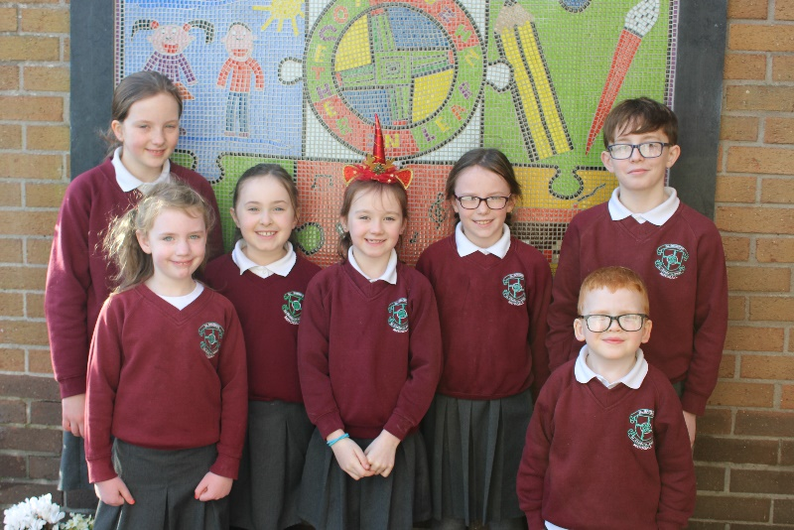

**Credit Union Art Competition:**

[](http://carnglencu.com/)

The theme of the Credit Union Art Competition this year was **“Walk of Life”**.

Well done to all our winners in the Credit Union Art Competition.

**7 years old and under 8 – 10 years old 11 – 13 years old**

Charlie Carmichael Eimear Conway Henry Curley

Sarah O’Neill Jessica Cushnahan Eadaoin Doherty

Eireann Maguire

**Thanks to Bannvale Credit Union for their very generous prizes.**

**Swimming:**

P6 pupils started swimming lessons on Tuesday 4th February at Greenvale Leisure Centre. This is a compulsory aspect of N.I. P.E. Curriculum.

**3, 2, 1 Book Fair:**

On Wednesday 5th February our 3, 2, 1 book fair arrived. Sales totalled £723.00 which meant

commission of £373.80 which was spent on extra reading resources for our new Accelerated

Reading Programme.

**New Pupil:**

On Wednesday 5th February we were joined by new pupil Bethan Allen who joined our Primary 4 class.

**Sacramental Talk:**

On Wednesday 5th February we held our Sacramental Talk for our P4 and P7 pupils and parents at 7:00pm in the school. This informative meeting enabled families to prepare for First Penance, First Holy Communion and Confirmation led by the Diocesan Catechetical Team. The Derry Youth Community worked with the P4 and P7 pupils on that evening as well in their classrooms. We had a very large turnout of parents to support our 38 P7s and 27 P4s – thank you, your support is greatly appreciated.

**Swimming Gala:**

On Thursday 13th February

Sadie Kilpatrick, Aideen Currie, Eadaoin Doherty, Katherine Convery, Aine Young, Emily Walls, Elaine O’Neill

**Merit Assembly:**

Our January Merit Assembly was held on Friday 14th February. Our Merit Assemblies are held to celebrate pupil success in all aspects of school life. Award Winners were:

P1 - Cian Casey, Caitlin McGarvey, Ethan Doyle, Cathain Grieve

P1/2 - Maggie Doherty, Conall Duggan, Mazie Bradley, Isla Convery

P2 - Christopher Convery, Aodhan McCloy, Nessa Young, Emma Ward

P3 - Cassie McCloy, Eireann Maguire, Dylan Stokes, Georgia-May O’Connell

P4 - Megan Rose Keenan, Ruairi Duggan, Liam Devlin, Cara Gallagher, Matthew Duggan, Eabha

Holleran -

P5 - Kainagh O’Donnell, Andrew Murray, Riona McNeill

P5/6 - Rose McCormick, Callum Casey, Lucie McMullan

P6 - Chloe Keenan, Charley Canavan, Ella McErlain, Maria Convay

P7 - Aideen Currie, Janes McPeake, Ronan Duggan, Rory Boyle, Ciara Dillon

**Accelerated Reading Awards:**

P5 - Martina Stokes, Jack Scullion

P6 -

P7 - Molly Davey, Aoibheann Pickering, Emily Walls

**Mid-Term Break:**

**Both staff and pupils had a very enjoyable mid-term break from 17th – 21st February.**

**Snow Day:**

On Monday 24th February we had to close the school due to the snow and much to the delight of all our pupils Mid-Term was extended by another day! We appreciate that school closures prove difficult for working parents and the decision to close in not taken lightly.

**B.A. Graduate Student:**

On Tuesday 25th February Mr Hugh McGurk (B.A. Student from St Mary’s University College) started placement.

**Ash Wednesday:**

On the morning of Wednesday 26th February the whole school walked up to Our Lady of Mercy Church for Mass and everyone got their ashes.

**P7 to Burnavon Theatre:**

On Wednesday 26th February our Primary 7 class went to Burnavon Theatre to see a production of “Under the Hawthorn Tree”.

**Golf Lessons:**

On Wednesday 26th February P7 pupils all had the opportunity to participate in a series of Golf lessons. The coach is PGA professional Tony Mulholland. These proved very popular – who knows we could have the next Rory McIlroy!



**Quizzes**

[](http://carnglencu.com/)

**Carnglen Credit Union Quiz:**

On Friday 31st January Carnglen Credit Union held the local heat of the 2020 quiz in Maghera Leisure Centre. St Brigid’s P.S. had three teams taking part, two in competition A which consisted of ten rounds for under eleven group and the other team in competition B which had twelve rounds for under thirteen pupils. The questions covered a diverse selection of general interests

with some questions having an Irish aspect. Scores given after rounds three and six indicated very close competition and when the final results were given St Brigid’s pupils’ strong performances were rewarded with first and second places in competition A and runners-up in competition B. The team placed first in competition A (Aideen, Aodhan, Henry and James P7) collected the trophy for the school and their individual prizes and they were through to the Chapter final in Ballymena. The runner up in this section (Aoife, Conor, Isla and Lisa P6) were rightly delighted to have come so close to their P7 competitors. The runners up in competition B (Anton, Eimhear, Eva and Sadie) were just pipped for first place by a very narrow margin. Congratulations to all the children who put in big performances and continued the school’s tradition.

**Northern Ireland Primary Schools Road Safety Quiz:**

Aideen, Anton, Henry and Sadie represented St Brigid’s Primary School in the Mid Ulster Heat of N I Road Safety Quiz in Cookstown on Thursday 6th February. They joined contestants from over forty schools for a very competitive series of rounds that (thoroughly) tested the children’s knowledge of the Highway Code and general knowledge. The teams waited anxiously as the final scores were added and the results announced in reverse order. The team from Mayogall was delighted when their name was called last. The children had proudly lifted the trophy and their own individual trophies giving the school back to back wins.

**Cross countrY**

**Cross Country Finals at Mullusk:**

On Wednesday 22nd January St Brigid’s P.S. was again represented at Mullusk in Flahavans NI Cross Country Final by a team in both the girls’ and boys’ finals – the only school in the Causeway Heat to achieve this. The girls’ team (Leona, Isabelle, Sadie, Aoibheann, Niamh and Caitlin) lined up with over 200 other runners and found the congested start and damp conditions difficult initially. As the race progressed they put in a very good effort and regained lost ground and were pleased with their performance with Leona as the school’s top finisher in 15th place.

The boys’ team (Henry, Rory, Sean, Callum, Conan and Caolan) having been runners-up last year and having gained a Causeway record of being top team for four years in a row, defeating the three in a row previously held by St Columba’s PS were determined to put in a serious challenge. They successfully managed the mass start of 200 plus runners and continued to maintain a steady pace before the final push where they finished strongly with Henry fifth and Rory seventh. When the placings were totalled St Brigid’s team was thirtyfive points ahead, clear winners and N. I. champions. The teams returned to school delighted with their performances.

**Staff Training:**

In St Brigid’s P.S. we give a high priority to the professional development of all our staff. Listed below is a number of training and development events attended by staff:

January 15th M O’K Course at ABC

16th G O’H Course

17th C V on a Shared Education course

23rd S O’K and G O’H to Enthuse Training

M O’K to ABC

February 3rd P McC to Emotional Well Being

4th M O’K to Cluster Meeting

5th P McC to Emotional Well Being

A McG to SENCO Training Day

6th M O’K to meeting in Belfast

R D to Cumann na mBunscol meeting

28th G O’H to Leadership Pathways course at ABC



**Dates for your Diary:**

* **Road Safety Quiz 2nd March**
* **Cumann na mBunscol Quiz 3rd March**
* **Flavahans Cross Country Training Session 3rd March**
* **Exhibition of Birds of Prey 4th March**
* **Reading Assembly 5th March**
* **Service of Light and Enrolment 5th March**
* **First Confessions 9th March**
* **P7 Residential 11th March**
* **P2 and P4 Shared Education 11th March**
* **P5 and P6 Dairy Council 11th March**
* **P1 and P3 Shared Education 19th March**
* **All County Finals Meadowbank 23rd March**
* **Cumann na mBunscol Quiz in Cavan 23rd March**
* **South Derry Cross Country at St Patrick’s College 25th March**
* **All County Finals at Meadowbank 27th March**
* **Confirmation 3pm 28th March**
* **Credit Union Quiz in Dublin 5th April**
* **Easter Break 9th – 17th April inclusive**