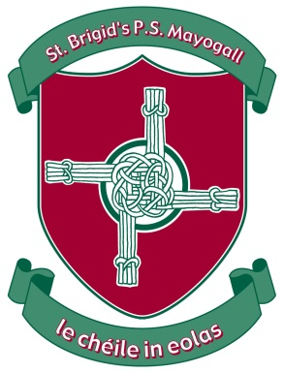St Brigid’s Primary School

Website: www.stbrigidsmayogall.ik.org

St Brigid’s Bulletin

News Letter

September / October 2019

**Term 1 Takes off:**

Term started on Monday 2nd September with 260 pupils. We were joined by 39 new Primary 1 pupils and Charlie Dillon P3.

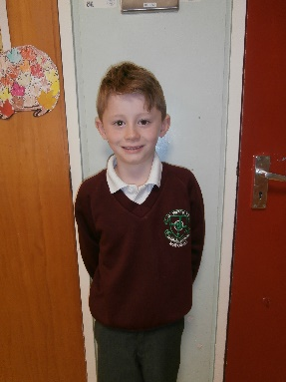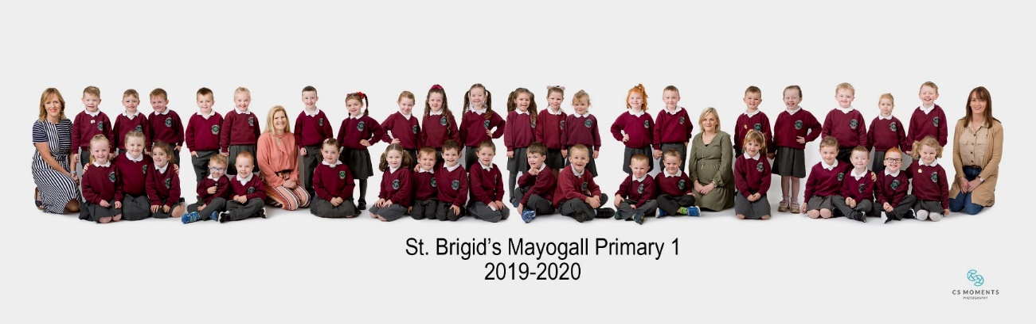

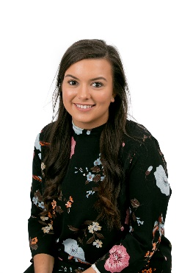

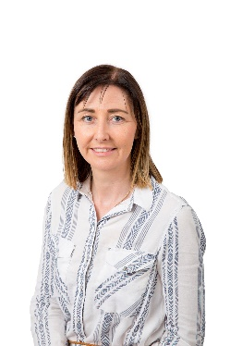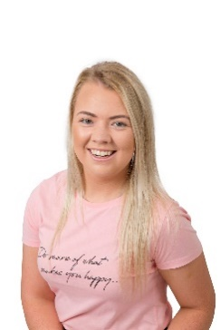**New Staff:**

We have a number of new staff who have joined us this

academic year. They are Miss Sile O’Kane in P5/6

returning from a career break and Miss Gráinne

Dobbin in P1 covering Mrs Mitchell’s maternity leave.

Roisin McDaid, Niamh Doherty, Betty Scott and

Colleen Traynor are our new Classroom Assistants.

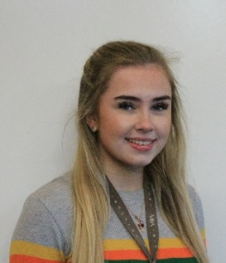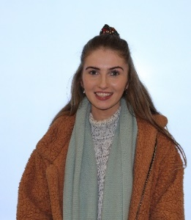

**Mass:**

Pupils from P4 – P7 will have a rota to attend Mass on Friday mornings in Mayogall Hall.

|  |  |  |  |  |
| --- | --- | --- | --- | --- |
| Primary 7 | 6 Sept | 4 Oct | 8 Nov | 6 Dec |
| Primary 6 | 13 Sept | 11 Oct | 15 Nov | 13 Dec |
| Primary 5 | 20 Sept | 18 Oct | 22 Nov | 20 Dec |
| Primary 4 | 27 Sept | 56 Oct | 29 Nov |  |

**Music Tuition:**

 Music Tuition started in September EA tutors Ms Helena

Nicholl began violin tuition and Ms Lauren Skelton began

Flute, clarinet and saxophone tuition with our pupils.

We have been very fortunate this year to be able to offer

more pupils the opportunity to start music tuition.

**School Photographer:**

On Monday 10th and Tuesday 11th September C S Moments Photography took our school photographs and feedback has been very positive.

**Science in St Patrick’s College:**

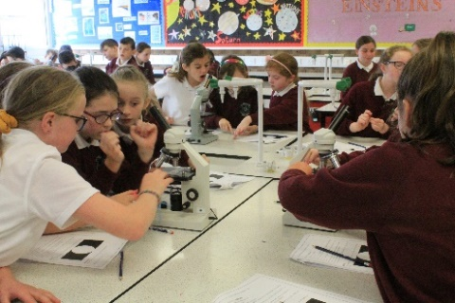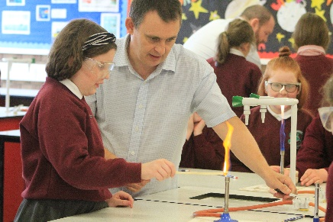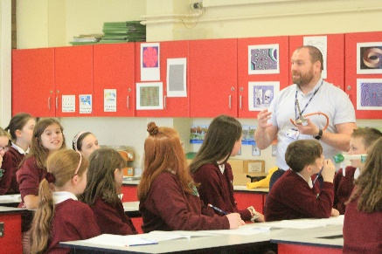

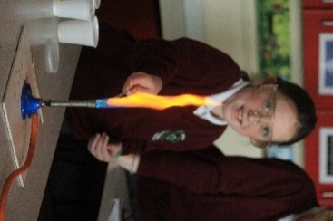

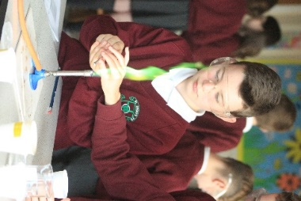On Friday 13th, 20th September 4th and 11th October Primary 7

continued their links with St Patrick’s College by visiting

Mr O’Kane for science lessons. They experiment using

Bunsen burners, different chemicals and different gases.

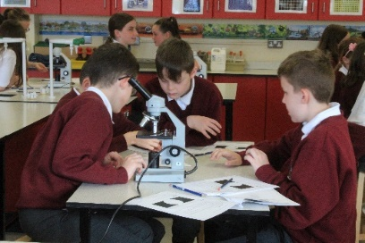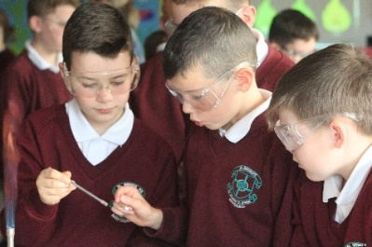

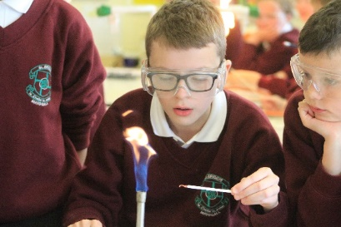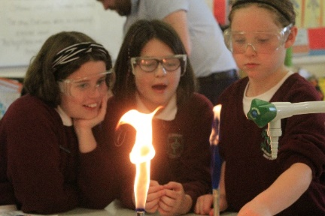

**Swimming:**

Half of our P7 pupils started swimming lessons on Tuesday 17th September at Greenvale Leisure Centre. The other half will commence their swimming lessons on Tuesday 19th November. This is a compulsory aspect of N.I. P.E. Curriculum.

**Fire Drill:**

We carried out our first fire drill of the school year on Thursday 19th September and completed it in 3 minutes 28 seconds but I think we can do better next time. This also was our first time to try out our new fire alarm system which we had installed during the summer as part of our re-wire.

**Drum Lessons:**

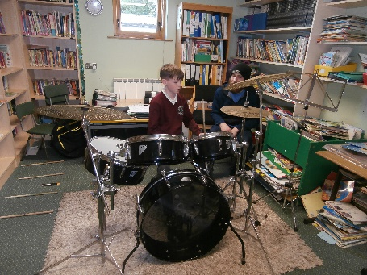

Fourteen of our pupils are taking part in one-to-one drum lessons with Mr Fionnbharr Ó hÁgain. Lessons began on 20th September for six weeks. Drumming is not only an exciting and fun way to express yourself but has also been shown to improve co-ordination and self-confidence. Our pupils are enjoying their six weeks of drumming.

**Work Experience:**

Emma Harkin a student at St Conor’s College Kilrea joined us for three days, work experience on Monday 23rd September.

Cara Hughes and Madison O’Neill both pupils at St Patrick’s College Maghera joined us for a morning of work experience on Thursday 17th and Monday 21st October.

**School Mass:**

We had our annual Start of Year Mass in school on Friday 4th October. Fr Graham welcomed all the children, many of whom had leading roles in the Ceremony. Mr Sean Scullion led the choir accompanied by Oonagh Clarke and the beautiful singing added so much to our Mass.

**Work Placement:**

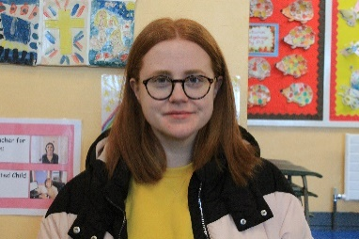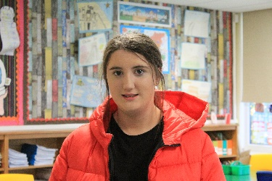

Clare McQuaide is on work placement on a

Monday and Friday from N.R.C. Clare will

be based in Mrs McCrum’s class.

Caoimhe Mulholland is on work placement

on a Tuesday and Wednesday from N.R.C.

Caoimhe will be based in Mrs McCrum’s class.

**Flu Vaccination:**

On Wednesday 9th October the majority of our pupils received the Flu vaccination.



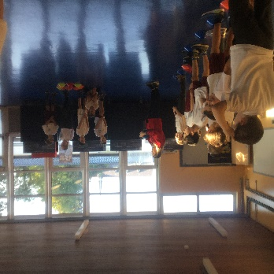

**Chest Heart & Stroke:**

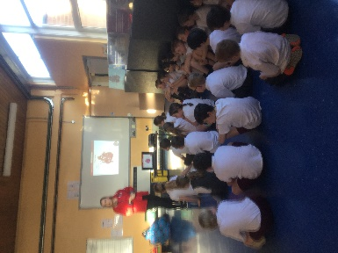

For three weeks in October, Primary 5 children were

involved in workshops with the Northern Ireland

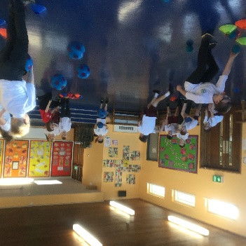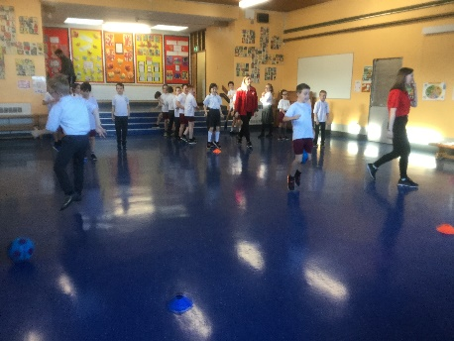Chest, Heart and Stroke Foundation. Across the

sessions the children took part in Chester’s Challenge

to help promote healthy habits in school and home.

The Primary 5 pupils gained information on how to

eat your way to health, physical activity and the heart

and how to unlock the treasure chest to good health.

BD07208_BD07157_**After Schools Clubs:**

SL00380_After Schools clubs began on Monday 7th October:

**Term 1**

|  |  |  |  |
| --- | --- | --- | --- |
| **DAY** | **ACTIVITY** | **FACILITATOR** | **AGE GROUPS** |
| Monday | Hurling | Mr R. Doherty | P6 – P7 |
| Tuesday |  |  |  |
| Wednesday | Girls’ Gaelic  Camogie  Hurling/Camogie | Mrs G. O’Hara  Miss G. Dobbin  Mr T. Walsh | P6 – P7  P6 – P7  P5 |
| Thursday | Boys’ Gaelic | Mr R. Doherty | P6 – P7 |
| Friday | Cross-Country | Mr E. Mulholland  Miss C. McKenna | P5 - P7 |

**Extra Sporting Activities:**

Primary 6 and 7 pupils had the opportunity to participate in Hurling and Camogie coaching sessions each Wednesday from 1:15pm to 3:00pm, starting from Wednesday 9th October. The sessions will be led by Derry hurler Tiarnan Walsh who will be representing the Derry County Board.

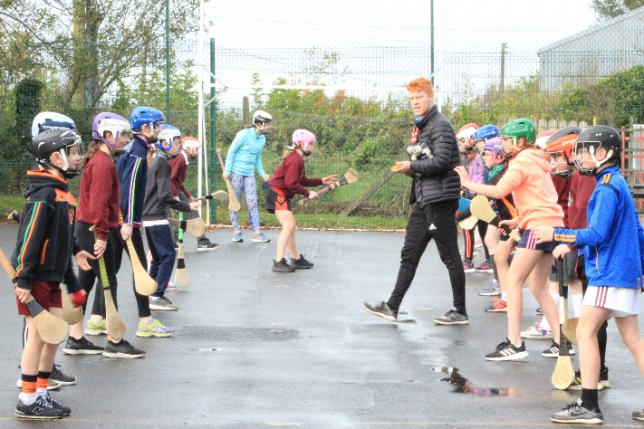

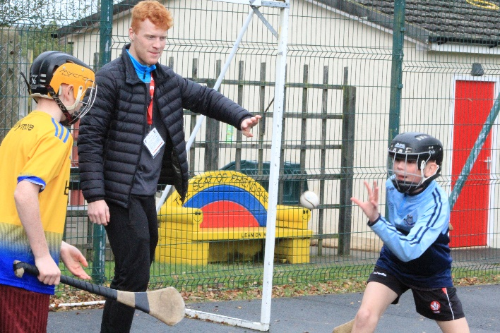

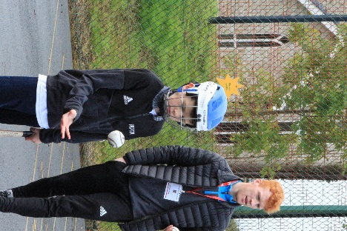

**School Census:**

On the 11th October the annual school census took place. In St. Brigid’s we had 256 pupils, 118 boys and 138 girls. 11 pupils had a Statement of Educational Needs. 144 pupils bought a school dinner and 20 pupils are in receipt of Free School Meals.

**World Restart A Heart 2019:**

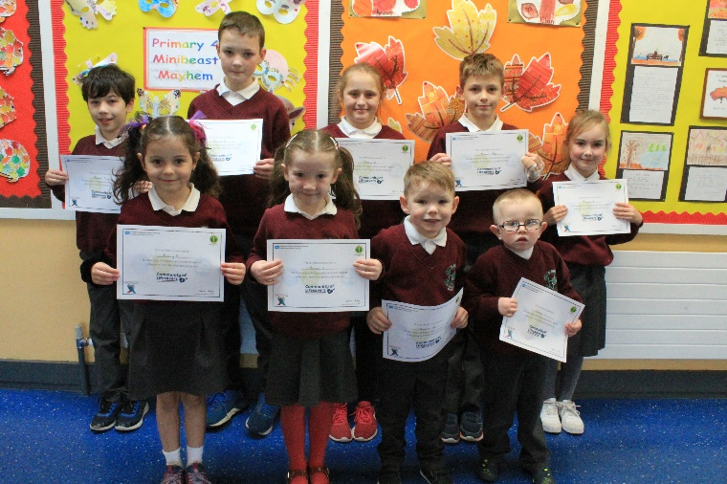**“All citizens of the world can save a life!”**

On the 16th October, all pupils from P1- P7 in

St. Brigid's celebrated the World Restart a Heart

(WRAH) initiative with CPR training.  All pupils

were trained in the basics of CPR and they even

located the school defibrillator which can be used

by our Parish community in the event of an emergency.

A cardiac arrest is the ultimate medical emergency

and it is when someone's heart stops and they are not

breathing.  Today, if you suffer an out of hospital cardiac

arrest in Northern Ireland, you have a one in ten chance

of surviving.  As a school, we wanted to equip as many

people as possible with the skills and knowledge to

potentially save a life in the future.

**Maths Week Ireland:**

[](http://www.mathsweek.ie/2017/)

St. Brigid’s P.S celebrated Maths week

Ireland from 12th – 20th October.

St. Brigid’s P.S were celebrating Maths week Ireland from 12th – 20th October 2019. All our pupils from P1 - P7 got involved to enjoy Maths and Numeracy lessons in support of this year’s theme “**Making Maths Count**,” along with 325,000 pupils across Ireland.

Then together as a family, our pupils were encouraged to improve their counting, estimating and measuring skills around the house. Well done and a huge thank you everyone for all the terrific calculating and counting!

***Some special congratulations also go to each of our class winners!***

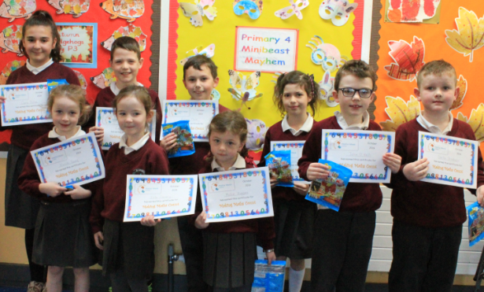

**Book Fair:**

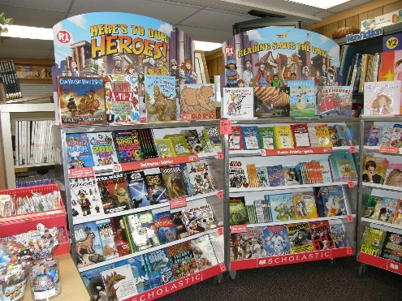



Scholastic Book Fair was held in the school from Wednesday

16th – 23rd October. Our book fair this year proved very

successful with a total of £1404.38 worth of books being sold.

This entitled the school to a commission of £782.63 which was

spent on extra reading resources for our Accelerated Reading

Programme.

**Parent Teacher Meetings:**

Parent Teacher Meetings were held on the week commencing Monday 21st October. We are delighted to report a 98% turnout.

**Merit Assembly:**

Merit assembly was held on Friday 25th October and the Award winners were:

**P1**  - Evie Boyle, Michael Duggan, Isla-Rose Coyle, Davinn Mullin, Cara Shaw, Jack O’Neill

**P1/2** - Cataleya Magill, Mollie McNally, Sarah O’Neill, Aoibhin Ward

**P2** - Caoimhe Brennan, Caoimhe Boyle, Peadar O’Boyle, Marc Sargent

**P3**  - Kealan Shaw, Daniel Boyle, Rory Kerr, John O’Neill, Grace Kelly, Rosie Birt

**P4** - Charlie O’Connell, Lena Young, Adam Harris, Michael McCloy, Eimear Conway

**P5** - Katie Birt, James Canavan, Oran Currie, Olivia McIvor, Caitlin McPeake, Aoibheann McTaggart,

Donal Ward, James Ward

**P5/6** - Karen Birt, Erin Hughes, Cormac Moore

**P6** - Serena O’Neill, Chloe Keenan, Isabelle Regan, Sean McPeake, Cathal Duggan

**P7** - Daniel Shaw, Erin O’Boyle, Henry Curley, Leona Martin, Annie Ward, Conor Sargent, Oisin

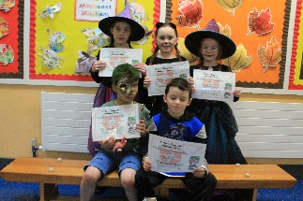 Henry

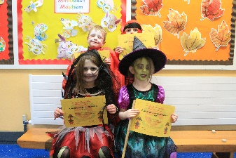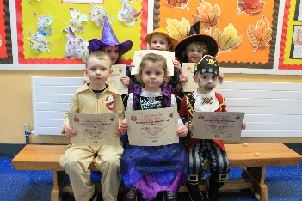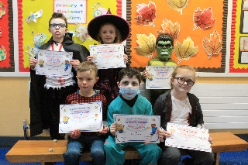

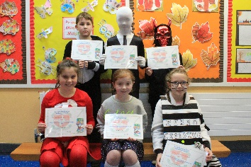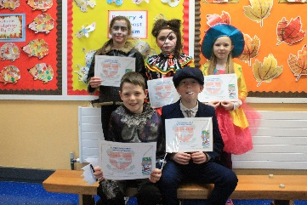

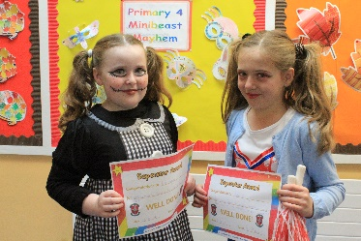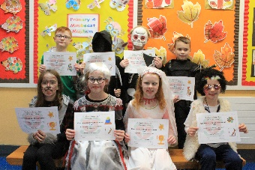

[](http://www.google.co.uk/url?sa=i&source=images&cd=&cad=rja&uact=8&ved=0CAgQjRw&url=http://www.freegreatimages.com/halloween-2014/&ei=KxdKVJPIHZX3apqUgqAN&psig=AFQjCNFUfBbzaLzQJtRJyZg-W8K29UA3pw&ust=1414228139630991)**Halloween Fancy Dress**

**and Fun Day**

On Friday 25th October the School Council organised a dress up day to celebrate Halloween. Pupils were allowed to come to school in their Halloween Costumes and there was a fancy dress parade with prizes for the most spectacular outfits. The prize winners were:-

P1 ~ Roisin Shivers, Charlie Carmichael

P1/2 ~ Cian Scullion, Erica Davey

P2 ~ Zoe Hearty, Peadar Boyle

P3 ~ Aoibhe Burke, Rory Kerr

P4 ~ Niamh Hendry, Adam Harris

P5 ~ Jacob Larkham, Riona McNeill

P5/6 ~ Peter Young, Rhian McErlean

P6 ~ Amber Sargent, Charley McGarvey

P7 ~ Daniel Shaw, Leona Martin

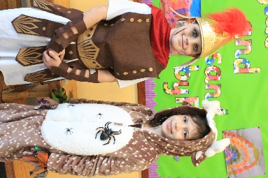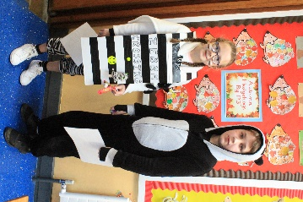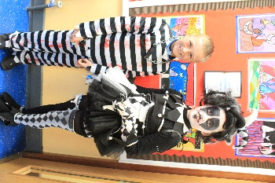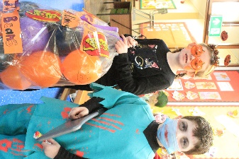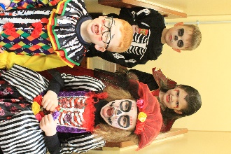

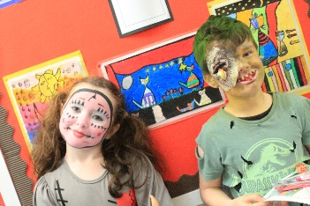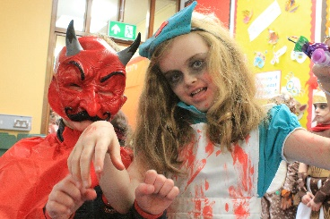

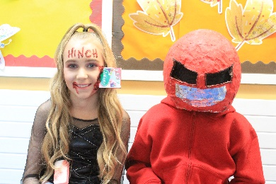

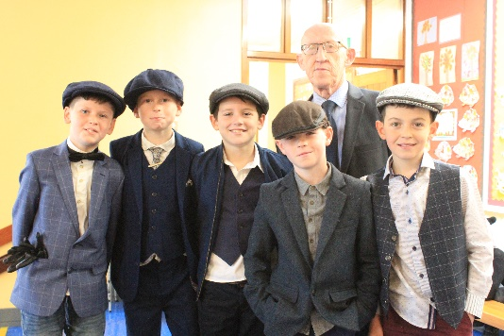

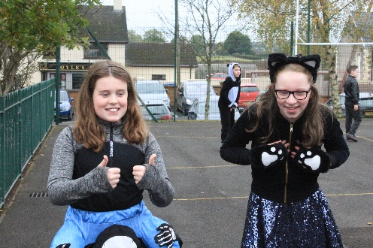

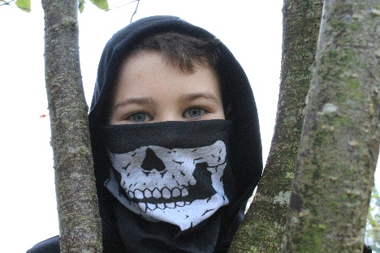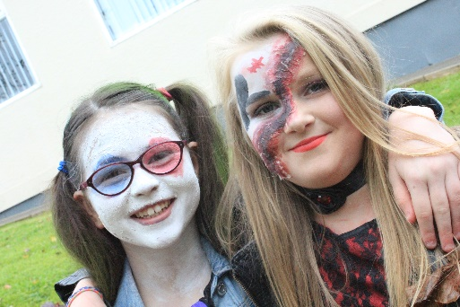

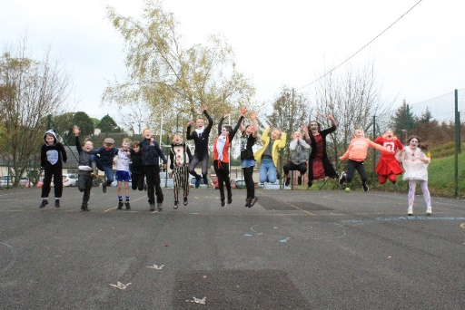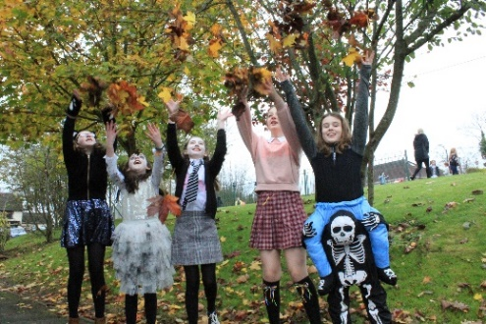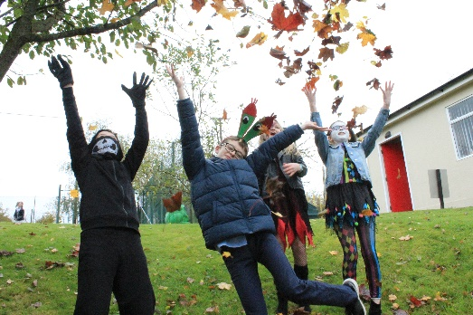



We are currently in our fourth year of the J.D.O. programme. We have partner schools in Denver, Massachusetts, Florida and El Paso (Texas). Primary 7 pupils are partners with Bradford K8, Denver. Primary 6 pupils are partners with Mt. Alvernia, Massachusetts. Primary 5/6 pupils are partners with Pelican Island, Florida. Primary 5 pupils are partners with Loretto Academy, El Paso.

All Key Stage 2 children have a partner that they communicate with regularly using their Google Chromebooks. The children complete a range of Literacy, Numeracy and World Around Us activities each month with their partners. We are very grateful to the J.D.O. organisation for supplying our pupils with a Google Chromebook.

**Quizzes**

**Scór na bpaístí Quiz:**

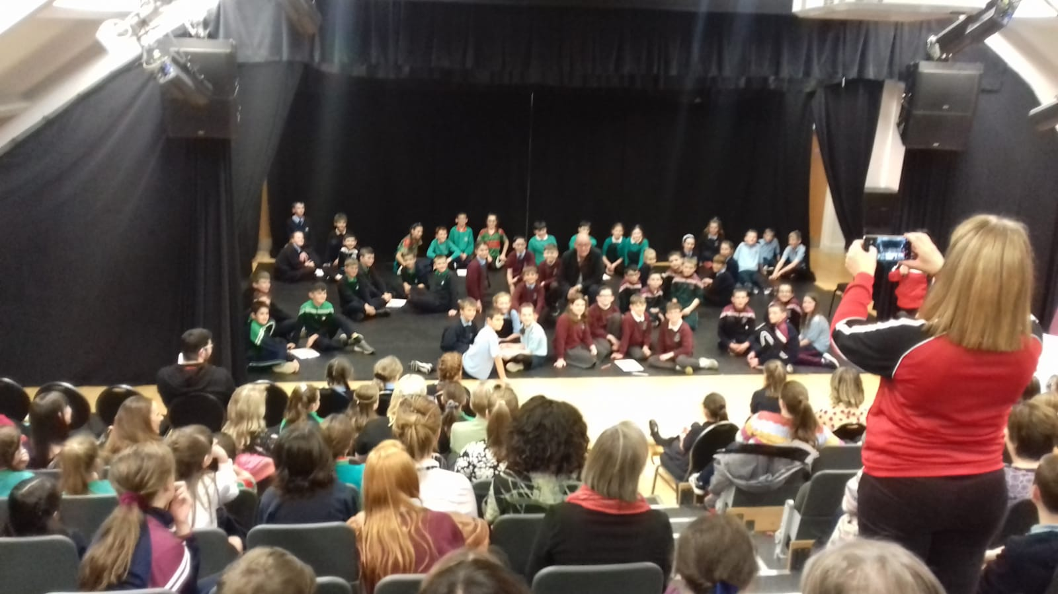

The first quiz was held on Thursday 24th October at An Carn, Tirkane. St Brigid’s team included Aideen, Aodhan, Henry and James. The 10 rounds covered topics with a strong Irish link – GAA, History, Geography, Politics, current events as well as a few rounds of wider general knowledge. At the mid-point the St Brigid’s team was in 3rd place and continued to put in a strong performance. When the scores were totalled at the end the team had 4th highest total. The children enjoyed the event and the challenge of their first quiz this year.

**Shared Education**

**Shared Education:**

We are delighted to be involved in the Shared Education programme with Knockloughrim Primary School again this year. Every child from Primary 1 to Primary 7 will be involved in the programme and will meet once each term with their friends from Knockloughrim P.S. The theme again this year is PDMU. Children will have shared lessons together and will have opportunities to visit each other’s school. All our teachers and the teachers from Knockloughrim P. S. met on Tuesday 8th October for an afternoon of planning this year’s activities.

**P5 Shared Education Trip:**

On the 7th October Primary 5 enjoyed a shared Education trip to the Burnavon Theatre in Cookstown with Primary 5 pupils from Knockloughrim PS. The workshop they attended was hosted by poet, Paul Cookson, which focused on his latest book Silly Poems. The children had great fun listening to his rhymes, joining in and created ideas on how to make their own poetry alongside with their own copy of Paul's book.

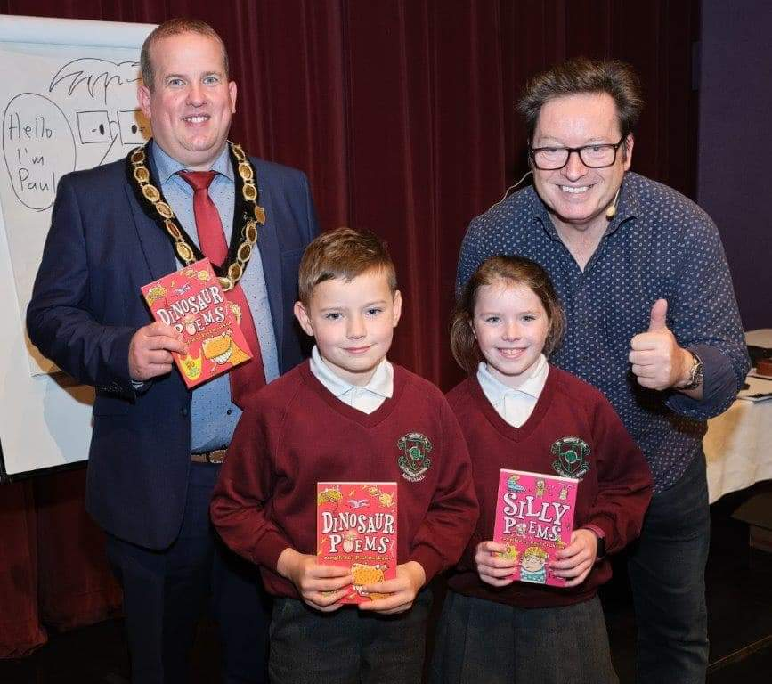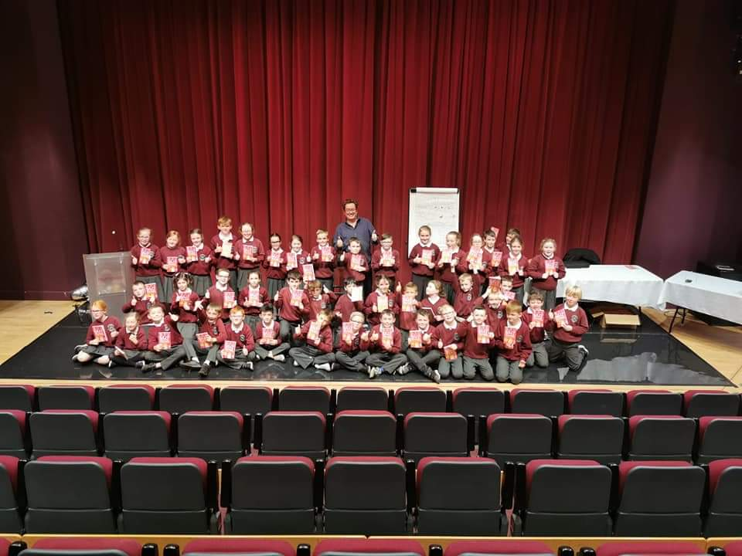

**Sports Events**

**Flahavan’s Cross Country:**

The new season of cross country is underway and there is plenty of enthusiasm from the increased number of pupils attending practice sessions on Friday evenings. There has been competition for places on the teams to represent St Brigid’s P. S. in the recent events. The first race, on 9th October at University of Ulster in Coleraine, gave the teams an opportunity to experience the challenges of a large field of runners. The girls’ team Aoibheann, Caitlin, Isabelle, Leona, Niamh and Sadie took 3rd place with Leona in 2nd place overall just two seconds behind the leader. The boys’ team Callum, Caolan, Conan O’D, Henry, Rory and Sean took 2nd place. In the congested start Henry was knocked over and another runner fell on top of him with the result Henry was unable to compete. Despite this upset the boys’ team ran strongly and finished in 2nd place, just twelve points behind the lead school. Rory was first finisher having set a blistering pace.

**Mid-Ulster Cross Country:**

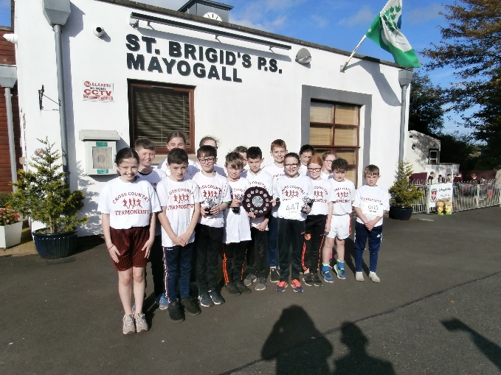

The second race, the qualifying round for Mid-Ulster Council competition was held at Tobermore on Thursday the 17th of October over 1200m. the girls team, above, was reinforced with the inclusion of Aine and Emily Rose while Conan B and Seamus Óg joined the boys’ team. In this event both St Brigid’s teams performed really well. The girls took 2nd place while the boys took 1st place. Leona was a clear winner in the girls’ race while Rory and Henry finished 1st and 2nd in the boys’ event. Both teams qualified for the final to be held at Cookstown.

**Staff Training:**

In St Brigid’s P.S. we give a high priority to the professional development of all our staff. Listed below is a number of training and development events attended by staff:

August 27th – 30th Baker Days

September 9th Shared Education Meeting in School

10th M O’K to meeting in St Patrick’s College

12th M O’K to Cluster Meeting

17th M O’K to SELF Conference in

20th M O’K and A McG to Learning Styles Analysis Conference

25th All Foundation Staff to Play Training with Clare Devlin

October 1st M O’K to Trauma information meeting

2nd M O’K to Primary Principals Conference

3rd R D and S O’K to Glen Primary School

C V, A H, C C, P McC, A McM and R D to training by nurse C O’Neill

8th All staff joined by Knockloughrim PS staff for a Twilight for Shared Education

9th Nurse P O’Hare to train all Foundation Stage Staff

10th M O’K to St Patrick’s College

10th – 11th S O’K to Shared Education STEM training

15th M O’K to Principals’ Conference

16th M O’K to Cluster Meeting

23rd M O’K to PQH

24th M O’Kane to ETI Training

Dates For Your Diary:

November 5th Cross Country Finals

Sean Marty Lockhart St Patrick’s College starts a 6 week PE programme with P7

6th Keeping Safe Workshops for all pupils

11th Anti-Bullying Week begins

P7 to Radar Centre Belfast

14th Fitness Freddy Fundraiser

18th Road Safety Week ‘Step Up For Safe Streets’

20th Universal Children’s Day

26th The Water Bus for KS2

28th Mental Health Day

December 4th Cross Country at Roe Valley Park Limavady

8th Official Opening of St Mary’s Church Lavey

9th School Mass for the Opening of St Mary’s Church

Christmas Dinner

10th Human Rights Day – ‘The Year of Indigenous Languages’

12th School Closed due to Election

18th Mass and Christingle in the Chapel at 7:30pm

23rd – 3rd Christmas Holidays

January 6th Whole school to Mass feast of the Epiphany

26th – 31st Catholic Schools Week

30th Dead line for New P1 applications 12noon

31st St Brigid’s Crosses

February 17th – 21st Mid Term Break

26th Ash Wednesday – Whole School to Mass

March 9th First Confessions

11th – 13th P7 Residential – East Coast Adventure Centre, Rostrevor

16th – 17th St Patrick’s Day break

28th Confirmation at 3pm in St Mary’s Church Lavey

April 9th – 17th Easter Holidays

May 4th May Day Holiday

25th – 26th May Holiday

June 6th First Holy Communion in St Mary’s Church Lavey

30th School Term Ends

**Note to Parents:**

**No adult is permitted to enter any classroom in St Brigid’s without reporting to the office first. This is a Child Protection issue and everyone must adhere to this. If you wish to speak to the teacher, or leave pupil belongings to your child you must always do this through the school office – no exceptions!**

**Parking**

Following official complaints, we have had to place cones in the bus lane at the front of the school. As you are aware it is against the law to park in an official bus stop. Some Ulsterbus drivers have been photographing cars parked in this area with a view to prosecution.

Unfortunately, we now have an increase in the number of parents who park their car in the school driveway. This impacts on school staff who are trying to turn into the school carpark, also causing a bottleneck and traffic jam. This impairs Danny’s sight of the road and traffic and presents a danger for our pupils crossing the road.

Please park in the Church Car Park and use the new footpath for the safety of all our children.

**Please remember the safety of all our children is paramount**

**DATA PROTECTION:**

Due to the new GDPR legislation, teachers are not permitted to give out class lists for birthday party invitation etc. If you wish to send in birthday invites, you can see the number of pupils in each class and also the number of boys and girls in the table below.

|  |  |  |  |  |
| --- | --- | --- | --- | --- |
| **Class** | **Teacher** | **Boys** | **Girls** | **Total in Class** |
| **P1** | **Miss Dobbin** | **14** | **12** | **26** |
| **P1/2** | **Mrs McCrum** | **P1 - 5**  **P2 - 0** | **P1 - 8**  **P2 - 8** | **21** |
| **P2** | **Mrs Vallelly** | **13** | **12** | **25** |
| **P3** | **Mrs Donaghy** | **15** | **20** | **35** |
| **P4** | **Mrs Quinn** | **10** | **16** | **26** |
| **P5** | **Mr Doherty** | **17** | **12** | **29** |
| **P5/6** | **Miss O’Kane** | **P5 - 11**  **P6 - 5** | **P5 - 5**  **P6 - 6** | **27** |
| **P6** | **Mrs O’Neill** | **14** | **15** | **29** |
| **P7** | **Mrs O’Hara** | **14** | **24** | **38** |

**Teachers will distribute invitations if you clearly specify whether it is all boys, all girls, or whole class invited.**

***Together in Learning………..***

***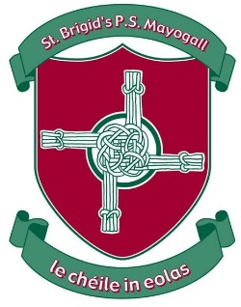***

The School Website!

**Our new school website is LIVE!**

**Please log on to** [**www.stbrigidspsmayogall.com**](http://www.stbrigidspsmayogall.com) **and see all our information.**

**We are adding information to our site so remember to check in regularly for updates.**

**In addition to school news there will be a class area where you can see samples of work.**

**In the Parents Area you will find:**

* **The School Calendar**
* **Dinner Menu**
* **Newsletters**
* **Holiday List**

**Our website is linked to our social media sites Facebook and Twitter. In addition, there will be a school App which you can download so that all the latest news will go straight to your phone!**

**Get school updates via your phone**



Our school is now listed in the **Schools NI** app, which allows you to view school updates and receive messages via your phone or tablet. The app is available on both Apple and Android devices, and will give you access to our school news, calendar events and letters.

To install the app, open **[School Website]** on your phone or tablet and click the ‘Download App’ button that appears at the top of the screen.



Next time you open the Schools NI App our school will be listed at the top of the list. You don’t need to have the app open to receive messages.

**Log on and look in . . . . . .**