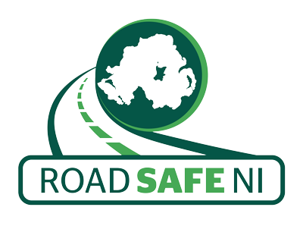
27th March 2020

Dear Parent / Teacher

Thank you for your interest in the colouring in competition for children in P1 – P4. We thought it might be a nice little activity to keep them busy while they are off school during this time.

I have attached the colour in sheets, the kids can complete as many as they wish. The closing date for the competition is Friday 15th May 2020. Entries can be returned by email to roadsafenicharity@gmail.com or posted to Davy Jackson at:

Road Safe NI
48 Copperthorpe
Drumahoe
Co. Londonderry
BT47 3LT

If you are returning by email please write the name of the child in the email and what primary they are in.

If you are returning by post, please write the child's name, address or telephone number (so we can contact you) and primary on the back of their completed entry.

Please feel free to share with any friends, parents or teachers that may also be interested in showing to the kids.

Take Care and Stay Safe.

Best Regards

_________________
Tricia O'Neill
Secretary

Road Safe NI

