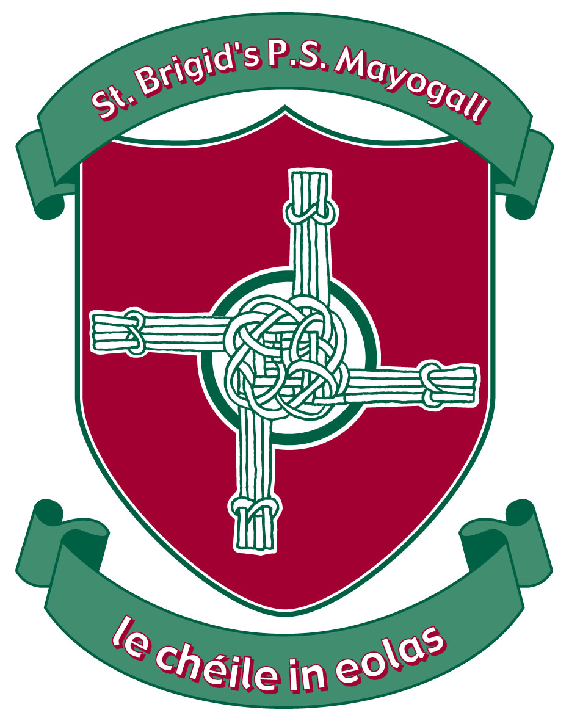

St Brigid’s PS Mayogall
September 2022

Introduction

Using ICT is one of the three Cross-Curricular Skills at the heart of the curriculum. Developing children’s digital skills encourages them to handle and communicate information, solve problems, pose questions and be creative in using digital technology.
Computers, tablets, programmable devices and digital cameras are a few of the tools that can be used to acquire, organise, store, manipulate, interpret, communicate and present information.
At St Brigid’s Primary School we recognise that pupils are entitled to quality hardware and software and a structured and progressive approach to the learning of the skills needed to enable them to use it effectively. The purpose of this policy is to state how the school intends to make this provision.

Rationale
Why should our pupils use ICT?
- ICT can enhance and enrich pupils’ learning across the curriculum.
- ICT provides pupils with learning and teaching experiences not readily accessible otherwise.
- ICT provides a vehicle for the development of pupils’ creativity.
- ICT can motivate and enthuse pupils.
- ICT can empower pupils, develop self-esteem and promote positive attitudes to learning.
- ICT gives pupils immediate access to high quality learning materials.
- ICT has the flexibility to meet the individual needs and abilities of each pupil catering for both weak and high achievers.
- ICT promotes access for pupils with learning difficulties.
- ICT offers potential for effective group work and collaborative learning.
- ICT supports different types of learners – audio, visual and kinaesthetic.



Aims

Our aims in using ICT in teaching and learning are to:
- extend and enhance learning across all areas of the curriculum.
- contribute to raising standards in literacy, numeracy and other areas of learning.
- encourage pupils to select and use ICT appropriate to the task.
- develop skills in the use of ICT and the ability to apply these skills in a range of curricular contexts.
- give children access to a variety of sources of information.
- instil in children a sense of confidence, achievement and enjoyment.
- enable pupils to extend their learning beyond the school environment.
- ensure teaching staff are motivated and skilled in the use of ICT and aware of the contribution ICT can make to learning and teaching.
- enable pupils to develop the skills of using ICT safely and responsibly in a safe learning environment.

Our aims in using ICT in Management are to:
- create, use and adapt high quality digital teaching resources.
- support communication with parents and the wider school community.
- encourage sharing of resources and good practice through ICT.
- increase professional efficiency by using ICT systems for planning, record keeping, reporting and communicating.
- enable the use of pupil performance data to inform strategic planning.

Strategies for use of ICT

- Since the focus of the Northern Ireland Curriculum is now on ‘Using’ ICT skills, ICT is not taught as a distinct subject, but is a tool to be used in a variety of meaningful contexts throughout the curriculum.
- ICT is planned and delivered as an integral part of each curriculum area to support and enrich children’s learning.
- All pupils are given equal access opportunities through management of ICT resources.

ICT and the Northern Ireland Curriculum
Literacy
- ICT is a major contributor to the teaching of Literacy
- Children learn how to draft, edit, and revise text.
- Children can create, develop present and publish ideas and opinions visually or orally.
- Children learn how to improve the presentation of their work by using publishing and presentation software.

Numeracy
- Many ICT activities build upon the mathematical skills of the children.
- Children use ICT in Numeracy to collect data, make predictions, analyse results, and present information graphically.
- They can explore mathematical models e.g. use of BeeBots, spheros and spreadsheets.

Personal Development and Mutual Understanding (PDMU)

- ICT makes a contribution to the teaching of PDMU and citizenship as children learn to work together in collaborative manner.
- They develop a sense of global citizenship by using the Internet.
- Through the discussion of moral issues related to online connections, children develop a view about the use and misuse of ICT in our everyday lives.
- They also gain a knowledge and understanding of the interdependence of people around the world.

Creative and Expressive

- ICT offers children the freedom to express their own ideas creatively through both image and sound and to experience the creativity of others.
- Children will have the opportunity to develop their creativity through a range of network software and digital technology.
- They can explore the Internet to gain access to a wealth of images and information about world famous pieces.

World around Us
- ICT transcends the barriers of distance and opens up the world as an easily accessible global community allowing children to experience the past, present and future of the world they live in.

Planning and Progression

Planning for ICT ensures coverage of the statutory requirements for ICT as set out under the 5 ‘E’s.
Explore
Express
Exchange
Evaluate
Exhibit

All pupils have opportunities to develop a wide range of skills and competencies appropriate with their age and abilities as they progress through the school from P1 to P7. Progression in key areas of ICT has been identified and agreed by all staff.
Progression is assured through a range of increasingly challenging activities covering all areas of ICT and embedded in the Northern Ireland Curriculum.

Each teacher has a checklist of competencies/skills to be addressed throughout the year.

Access and Resources

- All teachers have a Microsoft Surface Pro 7 Plus for use both in and out of school.
- Foundation Stage have access to a set of 22 iPads which are shared and used between the primary 3 classrooms. (P.1, P1/2, P2)
- A further set of 30 ipads are shared by Key Stage 1 classes. ( P3, P3/4, P4). Key Stage 2 class can access this set if needed.
- There are Mini iPads for use in the classes involved in the JDO Partnerships
- Key Stage 2 pupils have been allocated a chromebook each. (110 Chromebooks)
- Primary 4 pupils have chromebook each. (9 leftover JDO chromebooks + 20 C2K Chromebooks)
- P3/4 have 9 laptops
- All pupils have access to ICT through class-based computers and ActivPanels.
- All staff and pupils have access to the internet via workstations and the Wireless
- We have Speros, Beebots, Ozobots, Lego EV3, Lego Technic, Drones, BBC Microbits and ActivExpression Learner Response System, and are stored centrally and can be accessed when needed.

Resource | Location | Used by
11 Interactive Panels | All Classrooms | Staff and pupils
1 Interactive whiteboard | Library | Staff and Pupils
20 Dell Work Stations | 2 in Office | Principal and Secretary
20 Dell Work Stations | 1 in SEN room | SENCO + Staff
20 Dell Work Stations | 17 in classrooms | Staff and pupils
9 Laptops | P3/4 | Pupils/staff
42 iPads | 22 Foundation Stage  30 Key Stage 1 | Staff and Pupils
140 Google Chromebooks | Key Stage 2 | Staff and Pupils
1 ActivExpression Learner Response system (32 devices) | Stored in ICT Suite for shared use | Pupils
6 Beebots | Stored ICT suite for shared use | Pupils
STEM Devices  Spheros  Ozobots  Lego EV3  Lego Technic  Drones  BBC Microbot | P7 Classroom | Pupils
NOTES – New Devices

Access outside school
The school takes appropriate account of children’s ICT experiences outside of school. The school has an established website which the children and parents are encouraged to visit. Appropriate links to educational games and resources can be found on the website.

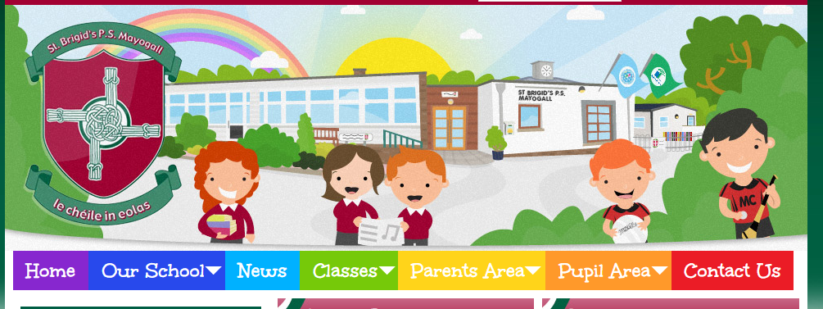

Some teachers in Key Stage 2 use Google Classroom to communicate, upload and disseminate work with their class.




Key Stage 1 and Foundation Stage classes use Seesaw to communicate with pupils and parents. Seesaw is used to celebrate classroom life and achievements. Activities can be assigned if and when needed.



Children have access at home to online numeracy programs
P1 to P3 can use Maths Seeds
P4 – P7 can use Mathletics
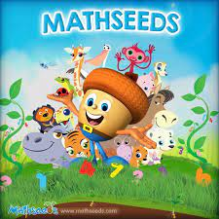

Inclusion

The school’s ICT facilities are available for use by all pupils and staff. All children will be given access to ICT regardless of gender, race, physical or sensory disability.
For pupils with learning difficulties and/or physical or sensory disability appropriate use of ICT can often enhance access to aspects of the curriculum. In co-operation with the SENCO we will endeavour to provide, wherever and whenever possible, appropriate software and hardware to enable such access.

Online Safety

The school has internet access in every classroom and in shared areas. Any use of the Internet will be strictly in accordance with the school’s Online Safety Policy. This policy has been communicated to and agreed by staff, pupils, governors and parents. Pupils are provided with opportunities to develop knowledge and understanding of e-safety and acceptable online behaviour at a level appropriate to their age and ICT capability. Teachers refer to Online Safety Policy in the school to address pupils learning. This is covered via the PDMU area of learning in class. The school recognizes Internet Safety Week each year by completing activities in each year group.

Monitoring & Evaluating

Teachers routinely evaluate their use of ICT in learning and teaching and the impact on pupil outcomes through six weekly evaluations of ICT.
The ICT Coordinator will monitor and evaluate teaching and learning using ICT on a termly basis. This will involve lesson observations, collecting samples of work and whole school moderation staff meetings.
Teachers maintain records of pupils’ ICT capability year on year showing evidence of progress in the five ‘E’s. Skills gained are recorded on a grid and passed on to the new teacher at the end of the year.
Pupils carry out evaluations biannually (February and June). It should be recorded in pupils PDMU books. Teachers have been given evaluation sheets to use or they may choose to use their own.

Assessment of ICT
The teaching and learning of Using ICT is a statutory curriculum requirement.
Before pupils carry out an assessment activity for Using ICT, they should have had opportunities to develop the range of ICT skills they need to carry out the activity with some independence.
3 tasks from the CCEA ICT Task Library are used for each key stage 1 and 2.
Primary 3 – 1 task
Primary 4 – 2 tasks
Primary 6 – 1 task
Primary 7 – 2 tasks
This ensures each child can be statutorily assessed at the end of each key Stage. Tasks are decided in each year in the second term. Tasks are chosen to align with topics/planners the teachers are working on. They must include at least 3 E’s and cover at least 3 Desirable Features.

Pupils in the Foundation stage will complete 2 tasks per year (December and June). The nature of the task and skills assessed will be agreed on each term by the Foundation stage teachers and ICT Coordinator. This will allow tasks to be topic specific.


School Development Plan

The school’s action planning for ICT forms part of the overall School Development Plan, identifying and prioritising areas for development. This is reviewed on an annual basis, taking into account developments in technology and outcomes of monitoring and evaluation procedures.

Staff Development

We recognise the need for the ongoing development of ICT capability to reflect the constantly changing nature of technology. We have a culture of continuing professional development of all staff, including support staff as appropriate. This will be provided in accordance with the school development plan and based on audits of identified need as well as developments in technology.

Review

Because of the rapidly changing nature of technology this policy will be reviewed on an annual basis by the ICT Co-ordinator, in consultation with the principal, teaching staff and governors.

This policy will be reviewed September 2023

Cathy Donaghy
ICT Coordinator

