St Brigid’s PS Circle Time Policy

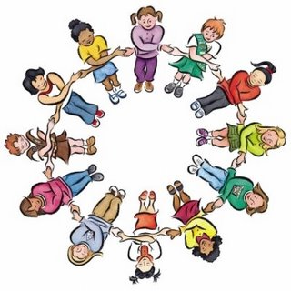

Review Date: September 2022

DEFINITION
Circle time is an important part of the school approach to developing independence in children and students and self a self regulating approach to managing behaviour.

AIMS AND OBJECTIVES OF CIRCLE TIME
Circle time can be used to raise concerns, problems and complaints within a class and to solve disputes. It can encourage students to begin to take responsibility for their own behaviour. It can offer solutions, support and strategies to individuals or groups when problems arise. It can be used to reinforce the class behaviour plan with the celebration of achievement and the awarding of rewards. Circle time is an important tool in the development of:- Self esteem in the individual
• Building group rapport
• Teamwork
• Social responsibility
• Problem solving
• Positive behaviour
• Pupil independence

IMPLEMENTATION
Circle time takes place throughout school and appears on the timetable as a dedicated lesson within KS1 and KS2 classes. Frequently it is incorporated into PDMU sessions for younger pupils. It works best when it is a regular feature of the week. Classes are encouraged to have their own dedicated box of circle time resources. Frequently puppets, toys and artefacts used regularly can provide emotional security. A suggested framework for a typical session could be:-
- Warm up/ energiser game – a chance to relax, have fun, address seating issues in informal manner
- Co-operation/ problem solving game – working together to solve a problem
• Time to talk – sentence completion, paired talks, small group talks, silent statements
• Plenary – Today I learnt...., the best bit today was.......
• Circle time games and activities can be structured to link in with current topics, themes or current affairs depending on the age and abilities of the participants. Sessions need not be long but better to be short, sharp and meaningful.

PROCEDURES FOR MONITORING
Training has taken place across the school and some Jenny Mosley books are available. Drop- in visits to classes by the coordinator will also take place. Timetables are monitored to ensure all classes have dedicated Circle time.

